Microsoft Word Accessibility
Melanie Thornton
Coordinator of Access and Equity Outreach
University of Arkansas Partners for Inclusive Communities
mthornt@uark.edu

Using Headings to Provide Structure

Apply a Heading
To apply a proper heading, highlight the heading text and select the appropriate heading from the styles group on the home tab.
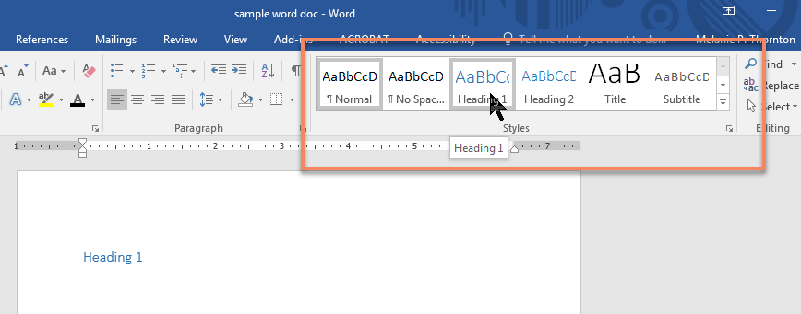
Keyboard shortcut: CTRL + ALT + 1 (for Heading Level 1)

Use Heading Styles Only for Headings
When you need to add emphasis or enlarge text that is not an actual heading, avoid using the headings styles to modify the look of the text. In that case, change the look and feel using the font group tools.
Keyboard shortcuts for applying styles without using headings:
Bold: CTRL + B
Italic: CTRL + I
Decrease font size: CTRL + [
Increase font size: CTRL + ]

Modify Heading Styles
Besides improving accessibility, using true headings in MS Word documents also offers an advantage to you, the document designer. If you are creating a long document and decide that you want to change the color of a heading, simply changing the heading style once will change all occurrences of that heading.
You can do this in two ways. Right click on the specific heading you want to change in the styles group on the home ribbon and select Modify. When the Modify Style window appears, make whatever changes you want to make in the style and select OK. The new style should be reflected in the style group.
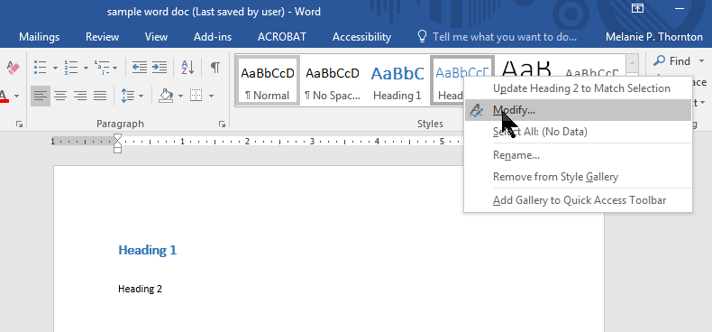

The other option is to change the style in your text and then to choose Update Heading 2* to Match Selection.
*Or whatever heading you are changing.
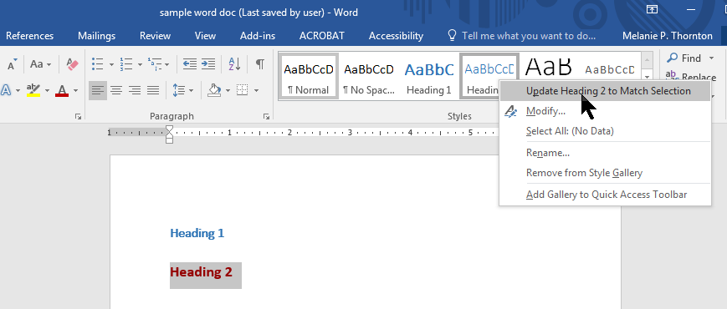
Either method will result in all headings of that level being changed to reflect the new look.

Making Images Accessible with Alt Text

Simple Images
A screen reader cannot discern the contents of an image. Alt Text provides a way to make the contents of the image accessible to a blind person who is reading your document.
- Right click on the image
- Choose Edit Alt Text
- (In older versions, you may choose Format Picture)
- Write the description in the box that appears to the right of the document.
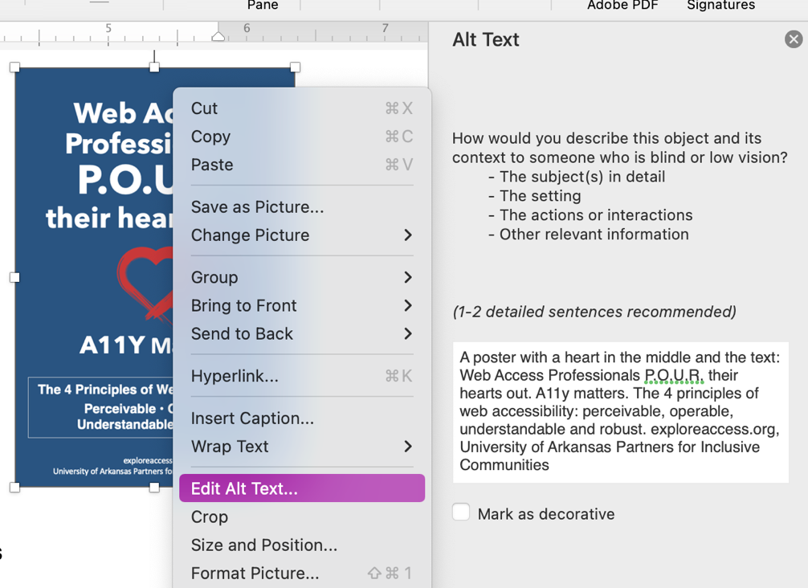
The ALT Text dialog box should appear to the right of your document.
Type a description of the image in the text field. There is no need to type “image of” or “picture of.” Simply describe what is in the image. The image used in this tutorial, for example, could be described as “A hammer and an egg side by side on a table.”

Creating Meaningful Hyperlinks
When creating hyperlinks, make sure the text associated with the link is understandable out of context.
Avoid this:
You may find this tutorial here.
Instead, do this:
You may find this tutorial on creating accessible documents on our website.
If the document is likely to be printed, you will also need to include the full URL. If the URL is A suggested format would be as follows:
You may find this tutorial on creating accessible documents on our website.
(http://exploreaccess.org/creating-accessible-documents/)
To create a hyperlink from the text, highlight the text you want to use for link. Right click on the highlighted text. Choose Hyperlink from the context menu.
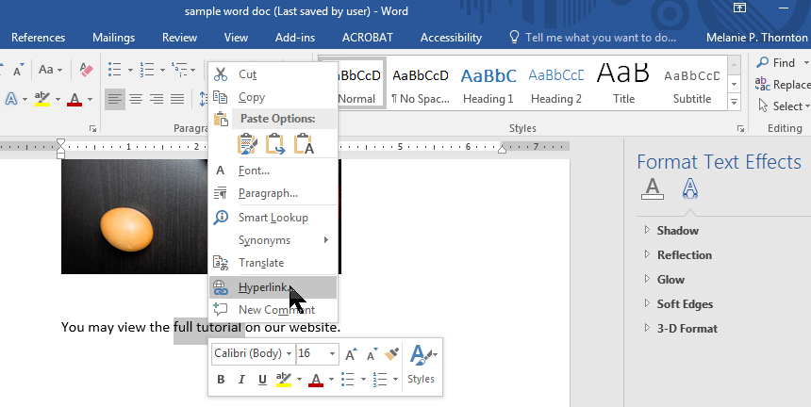
When the dialog box appears, make sure the text that you want to be included in the hyperlink is correct and add the URL below.
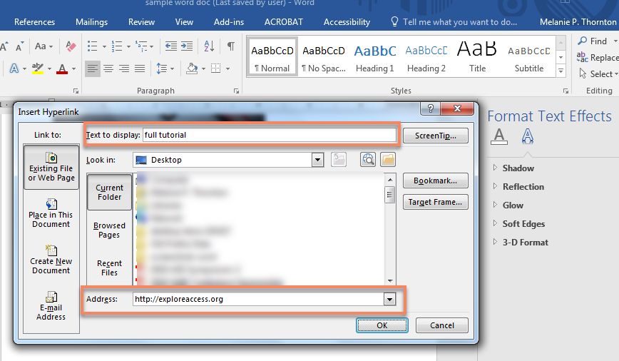

Learn More About Microsoft Word Accessibility:
- MS Word Accessibility Tutorial by MS Office
- National Center on Disability and Access to Education (NCDAE) Cheatsheets
- WebAIM: Microsoft Word

