Concurrent Session 2.1:
An Introduction to Digital Access for Disability Resource Professionals

- Jessica Stone, University of North Texas
Jessica.Stone@unt.edu
- Melanie Thornton, University of Arkansas
mthornt@uark.edu

What is Digital Access?
Digital accessibility involves the creation of websites, mobile applications and electronic documents that can be easily navigated and understood by a wide range of users.

Typical Barriers in Design
- Videos without captions
- Videos without audio description
- Images with no alt text
- Elements that require a mouse to operate
- PDF files that are saved improperly
- PDF files that are purely images
- Poor contrast
- STEM materials
It is much easier to create content with accessibility in mind, than remediate it later.

Who Is *Most* Excluded by Inaccessible Digital Design?
- People who are Deaf or Hard of Hearing
- People who are Blind, DeafBlind, Low Vision or Color-Blind
- People with Motor-Related Disabilities
- People with Dyslexia and other print-related disabilities

Alternative Ways of Navigating the Web
- Screen readers: Voiceover, JAWS/Fusion, NVDA
- Magnification Software
- Braille display
- Voice recognition software
- Keyboard only navigation
- Other mouse alternatives

What is WCAG 2.x?
- Stands for Web Content Accessibility Guidelines
- Developed by the World Wide Web Consortium Web Accessibility Initiative
- International standard
- Common standard for higher education is: WCAG 2.1 – Level AA

Remember P.O.U.R.
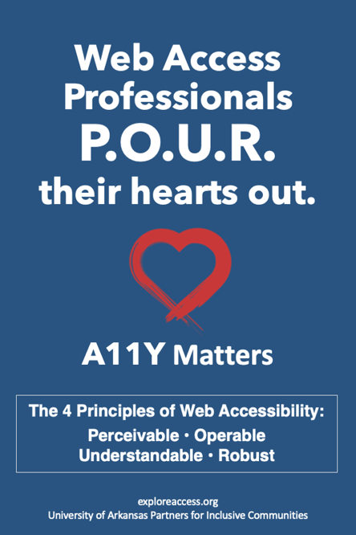
- Perceivable: Information and user interface components must be presentable to users in ways they can perceive.
  - Alt text, captions, audio description, color contrast
- Operable: User interface components and navigation must be operable.
  - Keyboard accessibility, visible focus, ability to pause elements
- Understandable: Information and the operation of user interface must be understandable.
  - Consistent navigation, reading level, language of page and sections, error warnings, predictability
- Robust: Content must be robust enough that it can be interpreted reliably by a wide variety of user agents, including assistive technologies.
  - Following markup guidelines and semantics

Limitations of Automation
- Automated testing
- Manual testing
- Overlays
- AI-generated transcription
- AI-generated descriptions of images
- Accessibility checkers

Working with Third-Party Vendors
- VPAT: Voluntary Product Accessibility Template is a standard template that vendors can fill out to describe how their product conforms to accessibility standards.
- A VPAT doesn’t always tell the full story.
- Learn to ask lots of questions of vendors.
- Ask your colleagues if they have experience with products.

Modeling Digital Access
- Word Docs
- PDFs
- PowerPoint
- Emails
- Social Media
- Any audio/visual content created
- Your Departmental Website

Microsoft Word – 3 Tips
- Structure document with true headings.
- Add alt text to all images.
- Instead of pasting URLs, provide meaningful links.

Microsoft PowerPoint – 3 Tips
You already know how to add alt text and create meaningful links!

- Choose slide designs with good contrast.
- Use simple fonts of 24 point or greater.
- Choose best slide layout for your content.

Suggested Resources:
- Law Office of Lainey Feingold
- OCR Video Series on Digital Access
- UNT Compliance Checklist
- WebAIM
- exploreaccess.org

Suggested Sessions:

4.5: Quality Indicators for Guiding Systems Change in Higher Ed Digital Accessibility

5.1: Implementation Science: Effective Strategies, Processes, and Resources to Support Assistive Technology Implementation or Accessibility Initiatives Campuswide

8.5: Developing a Common, Shareable Accessibility Rubric for Educational Technology

