Understanding the Belongingness of Students with Disabilities
  - Morgan Leahy Baker, M.Ed.

Background
Belonging is when an individual person feels an emotional connection to a community. Belongingness has been reported to be a human need and can have an impact on college student outcomes. If collegians struggle to fit in or feel they do not have a strong social support, then they become unmotivated and therefore, are less likely to succeed (Strayhorn, 2012). The Theoretical Model of Belonging for College Students with Disabilities stated that disability belongingness was generated by three factors: self-advocacy, social relationships, and mastery (Vaccaro, Daly-Cano, & Newman, 2015). The factors influence one another, as shown:
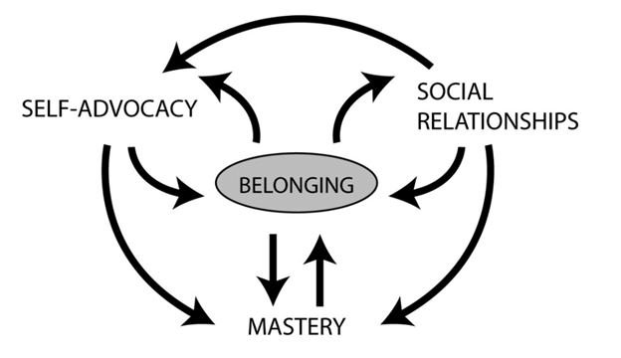
Fig. 1. Theoretical Model of Belonging for College Students with Disabilities (Vaccaro et al., 2015, p.677)

Purpose of the Study
The purpose of the study was to learn about the belongingness of collegians with disabilities. With the use of qualitative methods, belongingness of the students with disabilities was examined and factors that affect belongingness were explored. The study was guided by the following research questions:
- When navigating belonging, how do students with documented disabilities experience the connections between self-advocacy, social relationships, and academic mastery?
- Outside of the proposed model, which other factors do students with disabilities believe affect their sense of belonging on college campuses?

Methods
- Data was collected through semi-structured interviews over the course of three weeks at a large, private university.
- Narrative inquiry and phenomenology were implemented.
- Five participants were selected based on availability.
- Personal identifiers were removed to protect privacy.
- Interviews were broken into three parts: Understanding each participant’s (1) disability history and narrative, (2) experiences with the three disability belonging factors, (3) beliefs on the significance of other factors affecting belonging development.

Results
When considering the findings and connections between the three disability belonging factors, the three observed themes are as followed:
- Disability stigma played a role in disability belongingness.
- On-campus involvement impacted disability belonging development.
- Cultural identities influenced disability belongingness.

Disability Stigma
“It is the fear of mishearing someone or the fear of asking someone to repeat themselves and them thinking I wasn’t paying attention.”
- Difficulty disclosing disability.
- Decreased self-advocacy skills.
- Lack of connection to others.
- Little to no accommodations due to stigma from others.

Involvement
"Because of my ADD, I can never sit still, so I do a lot of extracurricular [activities] because it sets structure in my life."
- Increased inclusion.
- Alternative way to socialize.
- Stronger support network.
- Created a sense of purpose.
- Cultivated coping strategies.

Cultural Identities
"There was no concept of accommodations anywhere in my country. Accommodations are considered cheating and not very good."
- Affected perception of academic accommodations.
- Impacted ability to receive accommodations.
- Influenced disability identity.

Discussion
Overall, findings indicated that the disability belonging model is complex and cyclical—as intended by Vaccaro et al. (2015). Participants with disabilities felt that every experience or encounter that influenced their overall belonging development had one or more disability belonging factor present.
Though each theme included varying aspects of the disability belonging factors, findings implied that there are other external influences not necessarily addressed within the disability belonging model, including the significance of disability stigma and ableism, on-campus involvement, and cultural identities.

Implications and Future Directions
The study implied that though the Theoretical Model of Belonging for College Students with Disabilities is a strong, foundational model for understanding the experiences of students with disabilities, there is room for theoretical growth. Future studies should:
- Examine potential adjustments to the disability model.
- Investigate how belonging connects to the public versus private identities.
- Seek to understand why medically beneficial on-campus activities promote disability belonging.
- Examine gendered experiences in disability belonging.
- Explore how cultural identity impacts disability belonging.

Suggestions for Policy and Practice
- Mandatory disability competency training for faculty members.
- Mandatory cultural competency training for disability services staff members.
- Partnership between faculty and disability services.
- Better accessibility for on-campus opportunities.
- A designated platform for students with disabilities to voice their concerns/opinions and be heard.

