Equity & Excellence, Access in Higher Education: Exhibitor and Marketing Information
Boston, Massachusetts
July 9-13, 2019
AHEAD: Association on Higher Education and Disability
8015 West Kenton Circle, Ste. 230, Huntersville, NC 28078

Table of Contents
Welcome from Jane Johnston 2
Important Deadlines 2
Exhibit Hall Schedule of Events 3
Hotel Information 3
Exhibit Hall Map 4
Exhibitor Contract 5-7
Sponsorship Details 8-10
Advertising & Marketing 11

Welcome from Jane Johnston, AHEAD Manager of Member Services
Since 1977 AHEAD has been providing invaluable resources to professionals who work in disability services in higher education and beyond. AHEAD’s Annual Conference draws an average of 1200 attendees who seek to gain knowledge about disability services in higher education. Accessible technology, improving accommodations, postsecondary transition tools, universal design, and legal updates are just a few of the topics our attendees pursue.
You’re invited to join us July 9-13 in Boston, Massachusetts. We invite you to be creative! Put your company or organization in the spotlight. From sponsoring to exhibiting to presenting, you can leave a lasting impression on this important audience.

Feel free to contact me with any questions.

Sincerely,
Jane Ayres Johnston
AHEAD Manager of Member Services
jane@ahead.org / 704-947-7779 ext. 3301

Important Deadlines
April 1, 2019 - Last Chance for Early Bird Exhibitor Rate
May 25, 2019 - Advertising and Marketing Applications Due
May 31, 2019 - Final Advertisements Must be Submitted
June 1, 2019 - Exhibitor Applications Must be Submitted

Exhibit Hall Schedule of Events
The 2019 Exhibit Hall will be in the Westin Boston Waterfront. In addition to the schedule below, exhibitors are welcome and encouraged to stay for, and participate in, the entirety of the 2019 Conference that will begin with Preconference Institutes on Tuesday, July 9 (additional registration required) and end on Saturday, July 13.

Thursday, July 11
6:00 am - Noon Decorator Move In
Noon - 4:30 pm Exhibitor Registration and Move In
4:30 - 5:00 pm VIP Guided Tour
5:00 - 7:00 pm Exhibit Hall Grand Opening and President’s Reception

Friday, July 12
9:00 am - 4:00 pm Exhibit Hall Open (Activities in the Exhibit Hall include: Poster Sessions, Breakfast, Grab-and-Go Lunch, and Refreshments)

Saturday, July 13
9:00 - 11:30 am Exhibit Hall Poster Sessions and Extended Refreshment Break
11:30 am - 12:30 pm Exhibitor Breakdown
6:30 - 9:00 pm Awards Dinner (Exhibitors Welcome)

Hotel Information
Hotel rate: $205 per night; Please do not book until announced on ahead.org in March 2019

The Westin Boston Waterfront
425 Summer St, Boston, MA 02210

Exhibit Hall Map
The 2019 Exhibit Hall will be in the Westin Boston Waterfront. Shaded booths are reserved for those interested in sponsoring. While every effort has been made to ensure this drawing is accurate; this floorplan representation is subject to alteration and the Boston Fire Marshall approval and should be referred to for general illustrative purposes only.

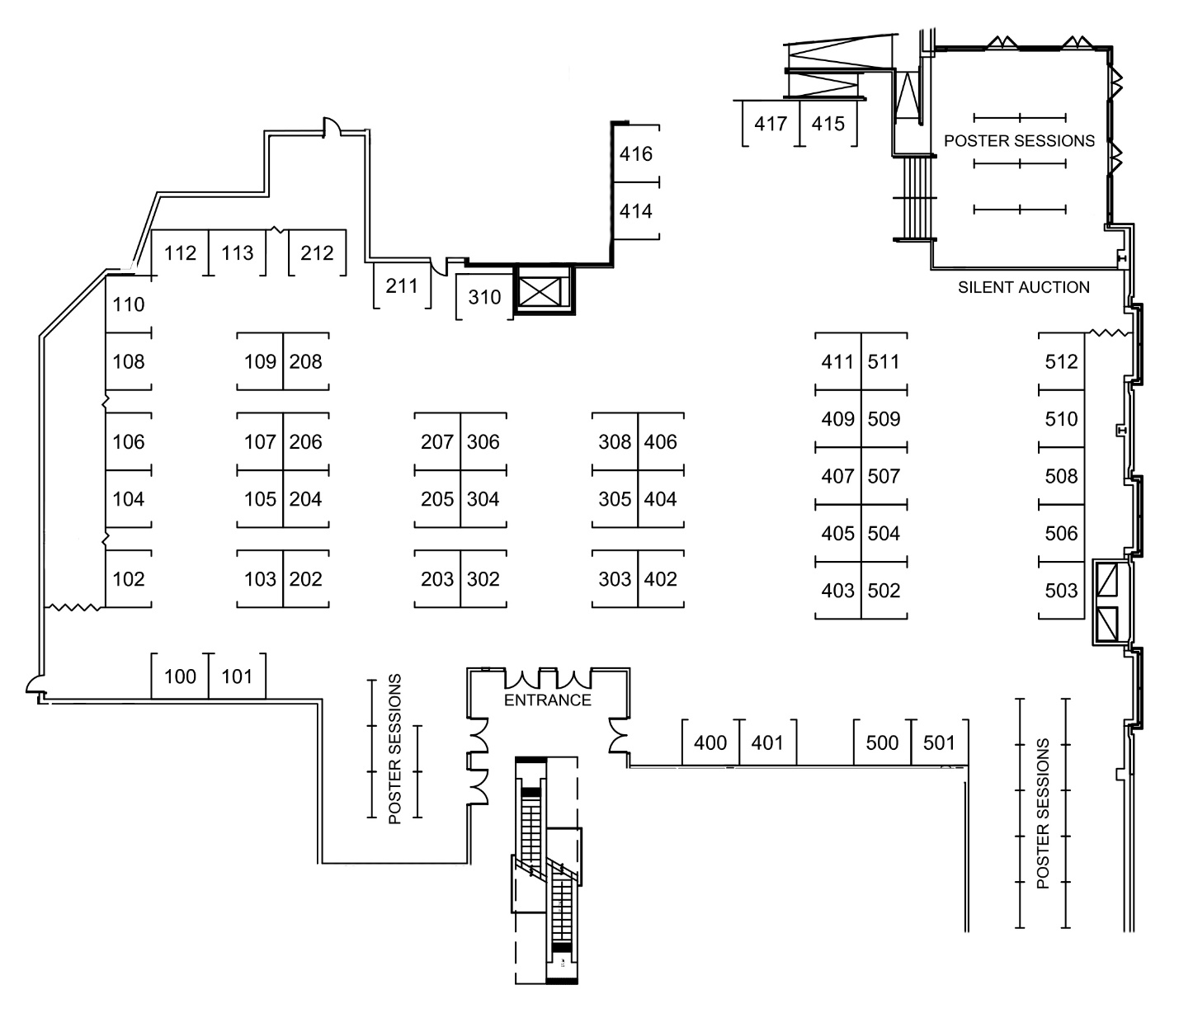

2019 Exhibitor Contract
AHEAD Conference & Exhibit Hall July 9-13, Westin Boston Waterfront

All exhibitors for the 2019 Conference shall, by completing the application form and forwarding same with payment as stipulated below, agree to each and every of the following points.

Application for Exhibit Space
All fully completed applications for exhibit space at the Conference shall be submitted to AHEAD 2019, 8015 West Kenton Circle, Suite 230, Huntersville, NC 28078. All exhibits shall relate to the activities of AHEAD and its members and shall not detract from the general character of the Conference. Accordingly, AHEAD reserves the right to reject any exhibit application, which it feels at its sole discretion, is not appropriate for the Conference. AHEAD’s decision will be final.

Exhibit Space Fees
The price of each exhibit space (booth) shall be twelve hundred and fifty U.S. dollars ($1300.00) for for-profit organizations and one thousand and fifty U.S. dollars ($1150.00) for not-for-profit organizations. All fees shall be paid in U.S. funds in full at the time of registration.

Assignment of Space
Exhibitors may request specific booths; however, booths shall be assigned by AHEAD in the event that the booth requested by an exhibitor has previously been assigned to an applicant whose application and mandatory deposit check were received at an earlier time. The number of booths, which an exhibitor may rent, shall be limited only by Exhibition Hall space requirements and limitations.

Application and Payment Deadline
The deadline for the receipt of an exhibitor’s application and payment shall be June 1, 2019 at 4 pm EST.

Cancellation Deadline
No refund shall be made to any exhibitor who cancels the contracted booth(s) after June 1, 2019. Further, no refund shall be made to any exhibitor who fails, for any reason, to occupy the space reserved. Payment, minus a $300.00 processing fee, will be refunded upon a written request for cancellation received by AHEAD before 4 pm EST on June 1, 2019. In the unlikely event that the Conference is cancelled by AHEAD, all monies shall be promptly returned to the applicants.

Standard Exhibit Area (Booth)
Each exhibit area (booth) shall consist of a space approximately 8’ wide by 10’ deep and shall contain one draped table, one chair, one sign, and a wastebasket. The height of all displays must not exceed 10’. The exhibitor shall adhere to decorum and good taste, as well as safety and structural integrity. No exhibitor shall erect any walls, partitions, paintings, decorations or other types of obstructions, which would interfere with the view of any other exhibitor’s booth.

Additional Furniture/Electric
Additional furniture (audiovisual equipment, internet connectivity, tables, chairs, etc.) and electricity will be available to the exhibitors at an additional charge. The exhibitor should forward such requests to the contracted decorating company via the Decorator’s Kit, which will be provided, to all confirmed exhibitors by May 17, 2019. The cost for such additional furniture shall be the sole expense of the exhibitor.

Exhibitors’ Badges
Included in the exhibitor’s registration fee shall be a standard sign for the booth with the exhibitor’s organization name, together with one Exhibitors’ Badge, which will allow entry to the Conference for July 11-13, 2019. Additional exhibitors (those in excess of the one included in the booth fee) will not be allowed to participate in the Conference unless they pay the full Conference registration fee. Additional Exhibit-Hall-only credentials can be purchased in advance for $100.00 each.

Exhibit Schedule
The tentative exhibit schedule is outlined in the preceding literature. AHEAD reserves the right to modify or change exhibit hours at its sole discretion and without advanced notice to exhibitors.

Display Setup/Dismantling
All exhibitors shall complete their booth display setup by 4:00 p.m., Thursday, July 11, 2019. All exhibits must be dismantled from the Exhibit Hall area no later than Noon on Saturday, July 13, 2019 and no sooner than 10:30 am that same day.

Security
Security personnel shall be provided on the evenings of Thursday and Friday, July 11th and 12th; however, neither AHEAD nor the Westin Boston Waterfront shall be responsible for the loss by theft or otherwise of any property of the exhibitor and thus recommends that exhibitors remove any portable technology or other valuables from the Exhibit Hall overnight.

Combustible Decorations
No combustible decorations shall be used at any booth at any time. All packaging, containers, excelsior and wrapping paper, which are not flameproof, must be removed from the exhibit floor and may not be stored under tables or behind displays. All muslin, velvet, silken or other cloth decoration must meet flameproof standards imposed and prescribed by the fire ordinances of the city of Boston, MA. All materials and fluids, which are flammable, shall be kept in city-approved safety containers. Open flames, butane gas and like items shall not be permitted on the exhibition floor.

Prohibited Posting
No decoration, poster, sign or similar items shall be posted on, tacked on, nailed, screwed or otherwise attached to any column, wall, floor or any other part of the Exhibition Hall building or furniture.

Distribution of Materials/Sales
The printed advertising or other materials of the exhibitor may be distributed only from within the exhibitor’s own booth. Drawings, contests, or lotteries of any kind and description may be permitted only if pre-approved by AHEAD. Direct sales by vendors are permitted so long as said vendor secures all required city, parish, and state licenses and tax permits in advance of the conference.

Alcoholic Beverages
Except as may be provided or sanctioned by AHEAD as a part of the general Conference, the sale, distribution and/or consumption of alcoholic beverages in the exhibit area shall be strictly prohibited.

ADA Compliance
The exhibitors shall be in full compliance with Title III of the Americans with Disabilities Act in all of its offerings of public information and services during the Conference, specifically including accessible formats of all printed materials.

Shipping Instructions
Additional information and shipping instructions shall be sent to each exhibitor within four weeks of the start of the Conference. All expenses related to shipping will be the sole responsibility of the exhibitor.

Payment of License Fees/Taxes
Exhibitors shall be solely responsible for the payment of any ASCAP or BMI licensing fees. AHEAD shall not be responsible for the payment of any such fee or tax, and the exhibitor hereby expressly holds AHEAD harmless for the obligation of the payment of any such fee or tax and further agrees to indemnify AHEAD in the event that a demand for the payment of any such fee or tax is made upon AHEAD.

Hold Harmless
Exhibitors shall hereby protect, save and hold AHEAD and the management of the Westin Boston Waterfront, their respective employees, agents, contractors and sub-contractors harmless from any and all claims for loss, costs, liability, expense or any other claim arising from, out of and/or by reason of the exhibitor’s occupancy and use of the exhibition premises or exhibition booth or any part thereof during the course of the Conference. The certification also extends to the payments of or liability for nonpayment of any fee or tax levied upon the exhibitor.

Conference Sponsorship Details
Become a sponsor at the AHEAD Conference and get exclusive access to attendees! Act now to get the sponsorship level best suited for your organization and use this unique opportunity to reach over 1100 - 1200 new customers. If you have another sponsorship idea, contact Jane Johnston, Manager of Member Services at 704-947-7779 or jane@ahead.org. Most sponsorships include (a) booth space and preferred location in exhibit hall, (b) advertising space in conference program book, and (c) literature distribution in attendees’ registration materials. All sponsorships include printed sponsor logo on all signs, literature, materials, ads related to the applicable event, and participation in the Online Exhibit Hall.

Overall Conference Sponsorship $10,000 (up to three available) or $25,000 for Exclusive Sponsorship
- Your logo and/or company name prominently displayed on the conference website and in the conference program book
- Two Exhibit Hall booths
- Up to four complimentary conference registrations
- Up to three pamphlets/brochures included in all conference bags
- Full-page ad in program book and pre-conference marketing
- Pre- and post-conference mailing list databases of members and attendees
- Partner membership to AHEAD for 2018
- Marketing in the Online Exhibit Hall and conference app

Professional Headshot Lounge Sponsorship $5500 (one available or two at $3000 each)
- Every Attendee who visits your booth gets a coupon for a professional business headshot
- Your logo and/or company name prominently displayed on the conference website and in the conference program book
- One Exhibit Hall booth
- One complimentary conference registration
- Full-page ad in the conference program book and pre-conference marketing
- One pamphlet or brochure included in all conference bags
- Marketing in the Online Exhibit Hall and conference app

First-Time Attendee Breakfast Sponsorship $3500 (one available)
- Named sponsorship of the breakfast, including prominent display of your company name/logo and a silent, captioned slideshow running throughout breakfast
- Your logo and/or company name prominently displayed on the conference website and in the conference program book
- One Exhibit Hall booth
- One complimentary conference registration
- One pamphlet or brochure included in all conference bags
- Full-page ad in the conference program book and pre-conference marketing
- Marketing in the Online Exhibit Hall and conference app

Coffee Break Sponsorship $3500 (two available)
- Named sponsorship of your designated break, including prominent display of your company name/logo
- Your logo and/or company name prominently displayed on the conference website and in the conference program book
- One Exhibit Hall booth
- One complimentary conference registration
- One pamphlet or brochure included in all conference bags
- One half-page ad in the conference program book and pre-conference marketing
- Marketing in the Online Exhibit Hall and conference app

Bag Sponsorship $2500 (two available)
- Your company name/logo printed on 1,200 conference bags and distributed to all attendees
- Your logo and/or company name prominently displayed on the conference website and in the conference program book
- One Exhibit Hall booth
- One complimentary conference registration
- One half page ad in the conference program book and pre-conference marketing
- Marketing in the Online Exhibit Hall and conference app

Gold-Level Sponsorship $3000
- One-hour Product Introduction presentation
- Your logo and/or company name prominently displayed on the conference website and in the conference program book
- One Exhibit Hall booth
- One complimentary conference registration
- One pamphlet or brochure included in all conference bags
- One full-page ad in the conference program book and pre-conference marketing
- Pre- and post-conference mailing list of members and attendees
- Marketing in the Online Exhibit Hall and conference app

Silver-Level Sponsorship (Gift Card Give Away Game) $2500
- Five $25 Visa gift cards to recognize members for visiting your booth. Gift cards will be randomly given out at designated times during Exhibit Hall high contact hours. Your participation in this promotion to draw foot traffic into your booth will be highlighted in marketing materials and the conference program book, website, and app.
- Your logo and/or company name prominently displayed on the conference website and in the conference program book
- One Exhibit Hall booth
- One complimentary conference registration
- One half-page ad the conference program book and pre-conference marketing
- One pamphlet or brochure included in all conference bags
- Marketing in the Online Exhibit Hall and conference app

Bronze-Level Sponsorship $1500
- Your logo and/or company name prominently displayed on the conference website and in the conference program book
- One Exhibit Hall booth
- One complimentary conference registration
- One pamphlet or brochure included in all conference bags
- Marketing in the Online Exhibit Hall and conference app

Charging Table Sponsorship $1500 (eight available)
- Named sponsorship of a charging table with prominent display of your company name/logo
- Your logo and/or company name prominently displayed on the conference website and in the conference program book
- One Exhibit Hall booth
- One complimentary conference registration
- One half page ad the conference program book and pre-conference marketing
- Marketing in the Online Exhibit Hall and conference app

Advertising and Marketing

Advertise in the On-site AHEAD Conference Program
The Conference Program contains information pertaining to sessions, presenters, and activities. All conference attendees, speakers, and primary exhibitor representatives receive a copy at registration. An invaluable tool, the Conference Program is referred to many times during and after the event.

Format for Conference Program: 5.5” x 8.5,” Full Color
Art must be in JPEG or PDF format at 300 dpi resolution or higher.

Advertising Specifications
Ad Size | Rates | Dimensions
Full Page | $750 | 5” x 8”
Half Page | $450 | 5” x 4”
Deadline for submitting Advertising and Marketing Application: May 25, 2019
Advertisements must be submitted by May 31, 2019

Advance and Follow-up Marketing: Keys to Success
Exhibitors and advertisers may purchase an AHEAD member mailing list (no emails) at a significantly reduced price of $350 (a $600 value). This benefit is your ticket to successful pre-show marketing and will be sent to you in early May 2019.Partner members receive a complimentary mailing list once AHEAD has processed your membership application.
All exhibitors and advertisers are also entitled to order a conference attendee mailing list for a cost of $200, which will be delivered in August 2019. Both lists may be purchased for a reduced cost of $400.

Reach Attendees Through Literature Distribution
You can have your literature prepackaged with every conference attendee’s registration materials. This is an effective and inexpensive way to capture the attention of over 1200 AHEAD Conference attendees, prompting them to seek out your booth in the exhibit hall. Placing your literature in the registration packet is also a great option for those of you who are unable to attend the conference.

Distribution Costs
Quantity | Non-Member Cost | Member Cost
One brochure/pamphlet | $350 | $280
Two brochures/pamphlets | $450 | $360
Three brochures/pamphlets | $550 | $440
Additional per piece over three | $100 | $100

Your company is responsible for providing the brochures/pamphlets. Please plan to provide at least 1200 copies.

