Hikers Guide: Engaging Administrators, Faculty and Staff in ADA Policy, Procedures, and Practices

AHEAD Conference 2018
Albuquerque, NM
July 19, 2018

Presenters:

Anne M. Moll, Ed. D.
amoll@coloradomtn.edu

And

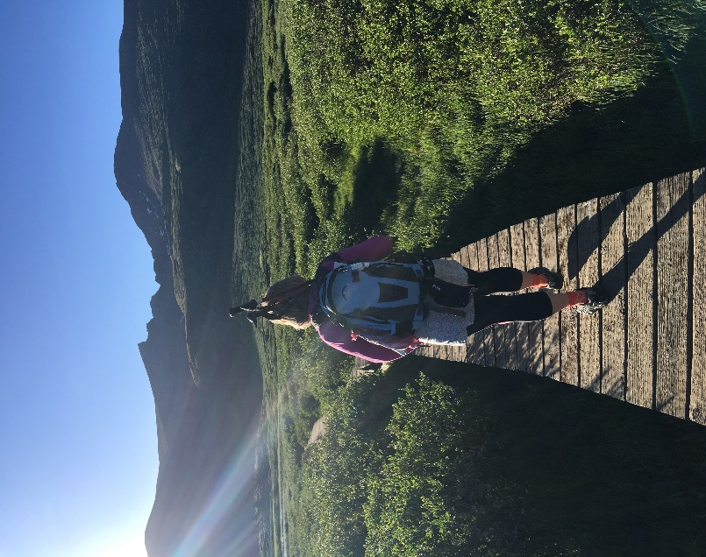
Lisa M. Doak, M. Ed.
ldoak@coloradomtn.edu
Colorado Mountain College

“A journey of a thousand miles begins with a single step.” Lao-tzu *

What should every leader know when hiking into the “Collegiate ADA” Wilderness?

Competencies of leadership, essentials for survivial and route planning are key to bringing administrators, faculty, and staff into the expedition of embedding ADA at the post secondary level.

Martin, Cashel, Wagstaff and Breunig (2006) offer 8 Core Competencies of Outdoor Leadership that apply directly to coordinators of ADA and post-secondary. We highlight five in this presentation as the necessary skills for any ADA service provider.

REI, one of the top adventure companies in the world, identifies 10 Essentials for Survival on any hike, no matter how short or long, vertical or flat. All apply when bringing colleagues on the journey of embedding ADA in post-secondary education. We offer a few additional essentials for the service provider to consider.

Authors Kelsey, Burns & Burns, and Enig, in their hiking guides offer Preparation and Route Planning fundamentals for any journey in the wilderness.

No one can tell you how the journey will end. It will be your story to tell.

Into the Collegiate ADA Wilderness: Initial Planning

Question: Where do you want/need to go and why go there?

- Foundational Knowledge
- Purpose
- Heritage
- Scope

Question: Who are the best hikers for the journey?

- Explore the competencies of personnel
- Think from broad to small group to an individual
- Consider skill balance
- Build excitement about the journey

Question: What are the routes/trails that get to the goal?

- Map out the plan
- Know the agencies and regulations that govern the area
- Use contemporary guide books like https://www.ada.gov; https://adata.org/factsheet/ADA-overview; https://www2.ed.gov/about/offices/list/ocr/publications.html
- Interview others who have been on the journey
  - Mentors, colleagues, individuals with disabilities
  - Ask about the landmarks, hazards, and beauty
- Scout the trail from different viewpoints
  - Think like…

Question: When is the best time to go on the journey?

- Consider the “Season” and conditions
- The window of opportunity?
- Is it the right temperature for this change?

Conditional Outdoor Leadership Theory (COLT) Adapted from Priest and Gass’

Increasing Favorability for Change |  | Decreasing favorability of Change
Minor consequence | Is the change of … | Major consequence
Few | Number of environmental dangers? | Many
Competent | Are the individuals involved… | Incompetent/untrained
Proficient | Is Leadership… | Deficient/uninformed
Unified | Is the Group… | Divided

Into the Collegiate ADA Wilderness: Packing the Essentials

- Navigation – tools to help you find your way
- Laws, Dear colleague letters, Mentors, Court cases

- Sun protection - prevent being burned
  - Document EVERYTHING
  - Communicate in all directions clearly, concretely and concisely
  - Policies and procedures

- Insulation - Keep things at an even temperature by putting on or taking off layers of pressure, expectations, outcomes

- Illumination - Be the one to shine light on the pathway
  - Be HIGHLY visible – safety teams, committees, mental health, student activities, faculty meetings, curriculum teams, etc.

- First aid supplies – things happen, be ready to step in and provide aid
  - Bandages - be ready with ideas of how to bridge a gap
  - Disinfectant/Cleaners – people will have “messy” experiences; they need a clean slate
  - Pain medication and antihistamines
  - Pen and paper
  - Nitrile gloves – for when things get messy

- Fire – waterproof ignition – don’t let the fire go out
  - Everyday items can light small fires
  - Know what can start and keep a flame of change going

- Repair kit and tools – when something in the system breaks
  - Knives or multi tools – tighten, loosen, adjust
  - Patch it up kits – for feelings, impressions, ideas

- Nutrition – mind, body, soul
  - Continuous nourishment is a necessity

- Hydration – the pressures make us sweat
  - Carry more than you need
  - Filters and locations of other sources
- Emergency Shelter
  - Protection from the elements
  - Safe havens for those who feel battered by the experiences

Moll’s Essentials
- The orange shovel – because if you are not careful, you will step in it!
- Hiking poles – who are your pillars of support
- Micro spikes – getting a grip
- Personal beacon/Communication system – so your friends can find you when you get lost

Into the Collegiate Wilderness: The Journey

The Successful Journey
  - Start small
  - Build your core strength
  - Let others tell their Story
  - Communicate where you are going and when you plan to get there
  - Be realistic about the journey

On the Journey
- Mark the path
- Junctions, milestones and important data
- Facilitate the trek but don’t be afraid to let experience be the teacher
- Keep the group together – avoid getting lost
- If you get knee deep in snow, mud or fog, think like the trail…

- Stay the course/trail even if it means getting dirty, wet or muddy
- It is easy to feel overwhelmed
- Consult your map often…

- Document the journey

- Stewardship
- Respect the environment
- Leave no trace

- Tell the story!

Resources
- Wilderness Navigation: Finding your way using map, compass, altimeter, and GPS. (2015) 3rd edition. Burns, B. & Burns, M. Mountaineers Books

- Climbers and Hikers Guide to the World’s Mountains (1990) 3rd Ed. Kelsey, M.R. Kelsey Publishing

- Mountaineering: The freedom of the hills (2011) 8th Edition, 50th Anniversary by the Mountaineers Books Enig, R.

- Outdoor Leadership: Theory and Practice (2006) Martin, B., Cashel, C., Wagstaff, M. & Breunig, M. Human Kinetics

- https://www.rei.com/learn/expert-advice/ten-essentials.html

