Fill form and email it to icc@viajestransvia.com . If you are paying by credit card it is convenient that you send a zip encrypted file using as password 2019CHAPMAN (in caps).

ACCOMMODATION RESERVATION FORM

CONTACT DETAILS:

PERSONAL DATA
First name: | Last name:
ID card No. or Passport No: | Phone:
Email:
University / Company:
City: | Country:

ACCOMMODATION OPTIONS:

☐ | 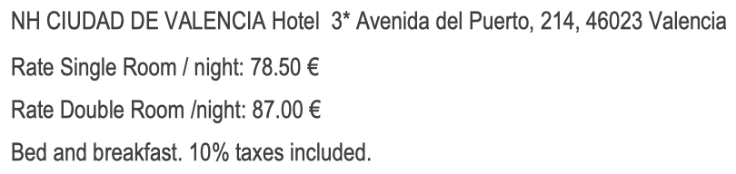
☐ | 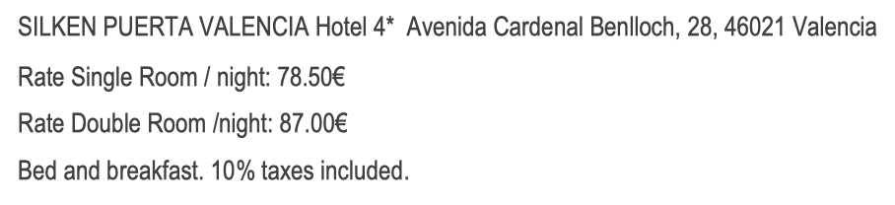
☐ | 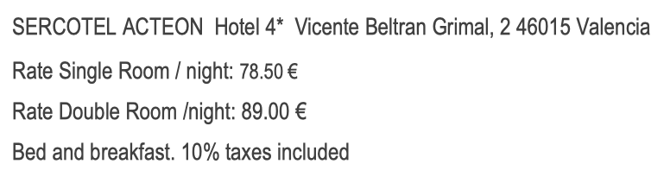
☐ | 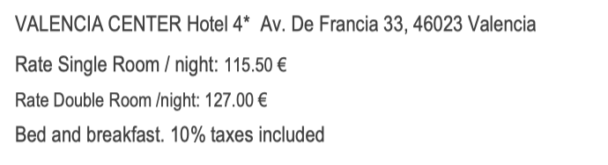
☐ | 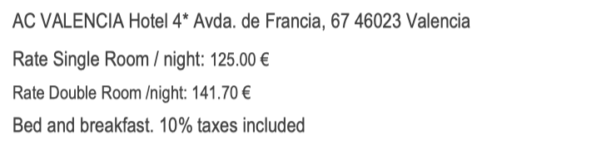

Rates are per room and night, breakfast included. In case a variation occurs on current IVA (tax), the final price will be adjusted to it.

Type of room: | Double ☐ 2 people | Single ☐ 1 person
Number of rooms: | Check in date: | Check out date:
Total Nights: | Rate per night: | Total amount:
Comments:

METHOD OF PAYMENT:

All reservations with bank transfer as payment method must be paid maximum 3 days after the confirmation of the reservation. Otherwise, the reservation will be cancelled automatically. Please include as transfer reference: Chapman 2019 + Full Name, and send the proof of payment by mail to icc@viajestransvia.com.

Bank transfer
To VIAJES TRANSVIA to the bank account: ES26 30582100172720102492 swift: CCRIES2A.
In order to confirm the reservation, please send us the bank transfer confirmation by email, together with this form filled in.

 |  | Credit Card
Type of credit card: ☐ MASTERCARD ☐ AMERICAN EXPRESS ☐ VISA
Credit Card Holder: |  |  |  |  | Credit card No:
Expiration date: |  |  |  |  | CVV: (Security Code)

INFORMATION REQUESTED FOR INVOICE:

INVOICE DATA
University / Company: | VAT Number:
Contact Person: | Phone:
Fiscal Address: | Zip Code:
City: | Country:
Email:

CANCELATION POLICY:

All accommodation cancellations must be sent in writing to TRANSVIA CONGRESOS by e-mail to icc@viajestransvia.com. Cancellations will not be considered effective until you get acknowledgement of receipt from the agency.

Minimum stay not required.

• Up to July 1st 2019, CANCELLATION WITHOUT EXPENSES
• From July 2nd to August 20th 2019 - PENALTY FEE OF 50% of the total roomnigths
• From August 21st 2019 - PENALTY FEE OF 100% of the total roomnigths

