
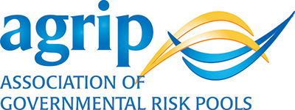

May 29, 2018

Dear College Graduate:

Congratulations on your graduation! As you begin life after college, the Association of Governmental Risk Pools offers you this advice: find a role that is fulfilling financially and supports your true spirit. Do something that uses all your talents, challenges you, and makes you feel good about your contributions.

You can make a difference in your career and your community by working in public entity pooling. Public entity pooling isn’t traditional insurance – it is a purpose-driven industry dedicated to improving local communities, schools, and public services. Pools help shape important local policies and decisions – from policing to school safety, investment in critical infrastructure like roads and sewers, recreational amenities like parks and bikeways, and more.

This is an exciting time to be joining the public entity pooling environment. New technology is bringing forward innovations like autonomous vehicles, drones, cybersecurity measures, public safety tools, and other opportunities for local governments and schools. Public entity risk pools work with local governments and schools to identify emerging risks and offer solutions that affect millions of people.

Public entity risk pools across the nation are hiring. This is an environment where you can find a career that’s rewarding personally, professionally, and financially. For more information about public entity pools in your area, visit the AGRiP Member Directory or reach out to us at info@agrip.org.

We wish you all the best, encourage your involvement in your local community, and hope you will choose to explore public entity risk opportunities.

Sincerely,

Ann Gergen
AGRiP Executive Director

#OpenLetterToCollegeGraduates
#InsuranceCareersMovement

