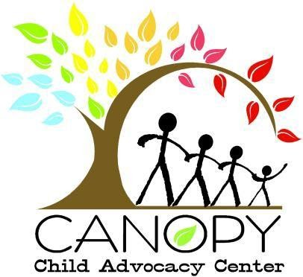

JOB OPENING
Director of Development

Canopy Child Advocacy center was established in 2019 to serve children and families affected by child abuse, envisioning a community where children are safe, families are resilient and those affected by child abuse are empowered to heal and thrive. This is done by coordinating a multi-disciplinary approach to services for children in crisis with many partners in the community including hospitals, courts, police, mental health services, and DCFS.

Canopy is seeking a strategic and mission-driven Director of Development to lead all fundraising efforts across individual, corporate, foundation, and government sectors. This role works closely with the Executive Director to design and implement strategies that attract new supporters and deepen engagement with existing donors. The Director also oversees the planning and execution of special events that advance Canopy’s visibility and fundraising goals.
The Development Director is responsible for maintaining accurate and timely donor database records to support strong donor engagement, recognition, and stewardship. This role also includes oversight of annual fundraising revenue and expense projections, as well as collaboration on financial reporting and analysis.

The Development Director also serves as a visible ambassador for Canopy Child Advocacy Center, representing the organization in community settings and engaging in outreach efforts to increase public awareness. This role contributes to public affairs initiatives by building and nurturing relationships with community leaders, partners, and media to enhance Canopy’s visibility and advance its advocacy goals. Experience in managing social media and website content is essential to support these efforts.

Qualified candidates will have a bachelor’s degree with at least four to six years nonprofit development experience. Master’s Degree and/or CFRE a plus. Excellent writing skills are essential. Passion for Canopy’s mission, commitment to the organization’s values, and the ability to work enthusiastically as part of a leadership team within the organization is required as is a strong commitment to the principles of diversity, equity and inclusion.

Salary range is $75,000 - $90,000 based on experience and qualifications. Interested candidates should send a resume, cover letter, and salary requirements by November 21st to: info@canopycac.org.

