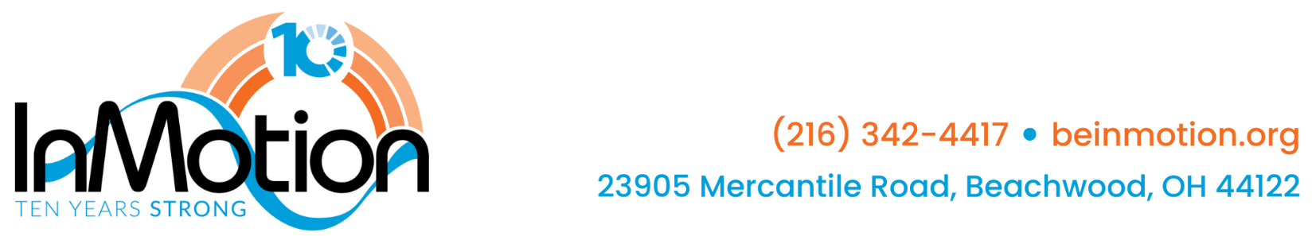
Position: Development Officer
Reports to: Chief Development & Communications Officer
Classification: Full-time, exempt
Salary: $50,000-$53,000
Competitive Benefits Package: Comprehensive medical, dental, and vision coverage; paid vacation, health, bereavement, and flexible time off; life insurance with Employee Assistance Program (EAP); and a SIMPLE IRA retirement plan with a 3% employer match after one year of employment.

The Development Officer will be a key member of the development team, with a concentration in successfully leading the annual appeal, donor stewardship and engagement activities, and growing a third-party fundraising program. Reporting to the Chief Development & Communications Officer (CDCO), the Development Officer (DO) will work closely with InMotion leadership to meet the organization’s fundraising goals. Responsible for managing donor relationships, soliciting gifts from donors, executing InMotion’s community fundraising program and monthly giving program, and preparing direct mail appeals. The Development Officer will engage InMotion clients and fundraising prospects to increase philanthropic support. Development Officer will also collaborate with InMotion team to plan and execute fundraising events and engagement opportunities.
InMotion prides itself on its commitment to developing transformational relationships with its prospects and donors. This value is woven into all annual plans, activities, campaigns, and communications aspects of the organization.
Essential Functions:
Development Program Management
- Actively participate in the creation of the annual development plan
- Use CRM and other software to manage relationships, schedule tasks and appointments, research and engage supporters, create dynamic reports, and manage donations
Annual Fund & Monthly Giving Program Management
- Manage and maintain giving society programs, including reporting and strategies for identification, cultivation, solicitation, and stewardship
- Develop and manage a robust community fundraising program, including donor education, outreach, messaging, and online fundraising strategies
- Develop and execute a strategy for increasing donor retention, including board member engagement, email communications, and donor stewardship
- In coordination with the CDCO and the Development Manager, plan and execute annual direct mail appeals, including list preparation, managing all aspects of appeal mailings, and coordinating involvement from Board members and committee members
- Identify, manage, solicit, and steward a portfolio of donors who have capacity to make a major gift ($5,000+)
- Manage the sponsorship committee for our annual fundraising event, including meeting scheduling, inviting new members, and relationship management
- Actively participate in cultivation activities designed to increase philanthropic support, including donor recognition and internal fundraising events
- In coordination with the CDCO and the Community Relations Director, write and execute direct mail and electronic donor communications, including gathering and organizing donor stories and client testimonials
- Regularly engage, solicit, and steward InMotion clients and fundraising prospects
- Assist CDCO in managing board members and solicitation partners to grow prospect list for individual and foundation giving

Other
- Attend outreach events with the Community Relations Director as needed to increase awareness of InMotion
- Collaborate with InMotion team to plan, organize and execute all internal events as needed
- Prepare event and donor reports as required
Qualifications
- Bachelor’s degree
- 3+ years in a nonprofit development position or equivalent experience demonstrating strategic, results-driven fundraising skills
- Excellent writing and overall communication skills (grant writing experience is a plus)
- Experience in annual fund-building, stewarding relationships, and gift solicitation
- Strategic thinker with a proactive approach to identifying opportunities, solving problems, and advancing fundraising goals
- Knowledge of comprehensive fund development plans, with direct experience developing and implementing these plans preferred
- Proficiency in Microsoft Office, CRM, and social media platforms
- Ability to thrive as part of a collaborative, high-energy, mission-committed team
- Commitment to the fundraising profession’s highest ethical standards

About InMotion®
InMotion® uses a community-based group approach to help people with Parkinson’s disease feel better every day. Located in Beachwood, Ohio, InMotion® provides evidence-based healing arts, physical wellness, education, support and symptom-specific programs that have been shown to slow disease progression and help people live well. InMotion® offers all programs at no cost to clients, and is a 501(c)(3) nonprofit organization that relies on donations from individuals, businesses, and foundations to fulfill its mission. Learn more at www.beinmotion.org.

Applicants should submit a letter of interest and resume to: Wendy Voelker, wvoelker@beinmotion.org. No phone calls.

