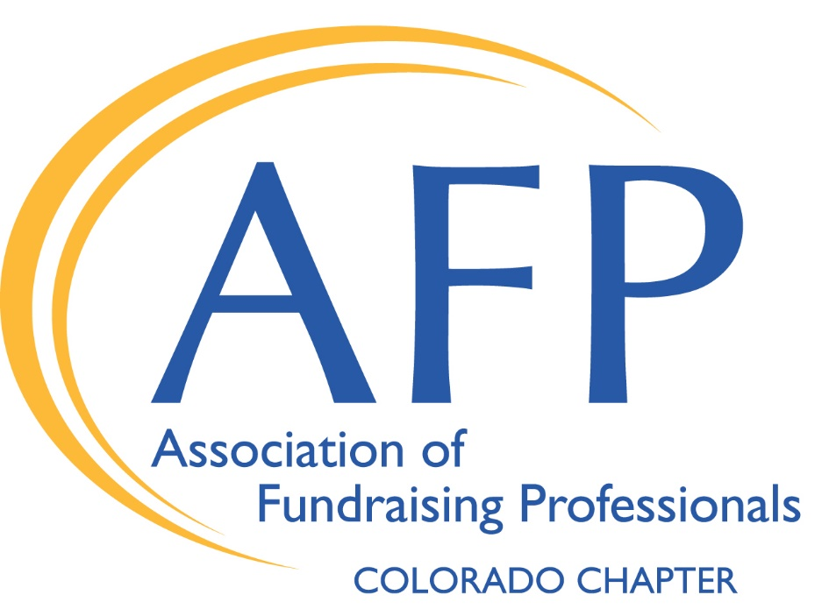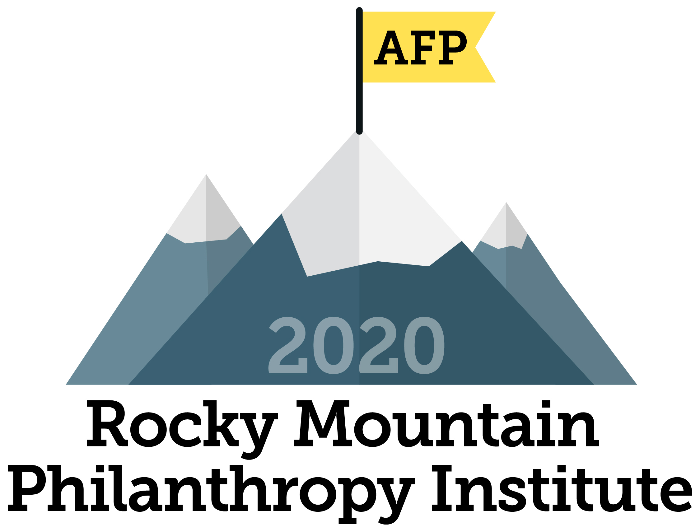

Association of Fundraising Professionals/Colorado Chapter
RMPI – “We Are Change Makers” September 11, 2020
Scholarship Application
Application Deadline: July 31, 2020 – No late applications will be accepted!
Awardees will be notified no later than August 21.

Scholarships are offered on a one-time basis. Individuals who have previously received an RMPI scholarship are not eligible.
Your Information

Applicant’s Name: Click here to enter text.
Job Title: Click here to enter text.
Employer: Click here to enter text.
Business Address: Click here to enter text.

City: Click here to enter text. State: Click here to enter text. Zip: Click here to enter text.

Business Phone Number: Click here to enter text. Cell Phone Number: Click here to enter text.

Email Address: Click here to enter text.
- My organization’s mission includes animal advocacy. ☐ Yes ☐ No

- How long have you been at your present job? Click here to enter text. Years Click here to enter text. Months

- How long have you been in the fundraising field? Click here to enter text. Years Click here to enter text. Months

- 3. Are you an AFPCC member? ☐ Yes ☐ No

  - If not, please comment on why not: Click here to enter text.

5. The scholarships awarded for this conference will be partial scholarships, so award winners will need to cover a $10 registration fee. How will you pay for the uncovered portion of the cost?
☐ I will pay for it personally ☐ My organization will pay for it

☐ I will split it with my organization. ☐ Other (please comment) Click here to enter text.

Continued on next page

6. There is a pre-conference virtual session for RMPI scholars on Thursday, September 10. This is a meet-and-greet session where you will have the opportunity to network with other scholarship recipients, meet RMPI veterans, and ask any questions you may have about the conference or AFP. Would you be interested in attending?

☐ Yes
☐ No

7. Please include an additional sheet to provide us with your answers to the following two questions:

A. Why do you want to attend RMPI?
B. Why do you need this scholarship?

8. Would you be willing to help us promote RMPI scholarships? Examples include speaking at an AFP program or writing an article for our weekly newsletter, Thursday Thoughts. Click here to enter text.

- AFP is committed to promoting diversity in its many forms. How do you embrace diversity personally and professionally? Briefly explain what diversity means to you.
Click here to enter text.

(Applicant’s Signature) (Date)

________________________________________________ _________________________________
(Supervisor’s Signature) (Date)

Please complete this form and email it to the address below by July 31, 2020. Thank you!

deann@afpcc.org
DeAnn Acosta, CFRE
Executive Director, AFP Colorado Chapter
Phone: 720.234.1050

Thank you to our Scholarship Sponsors:

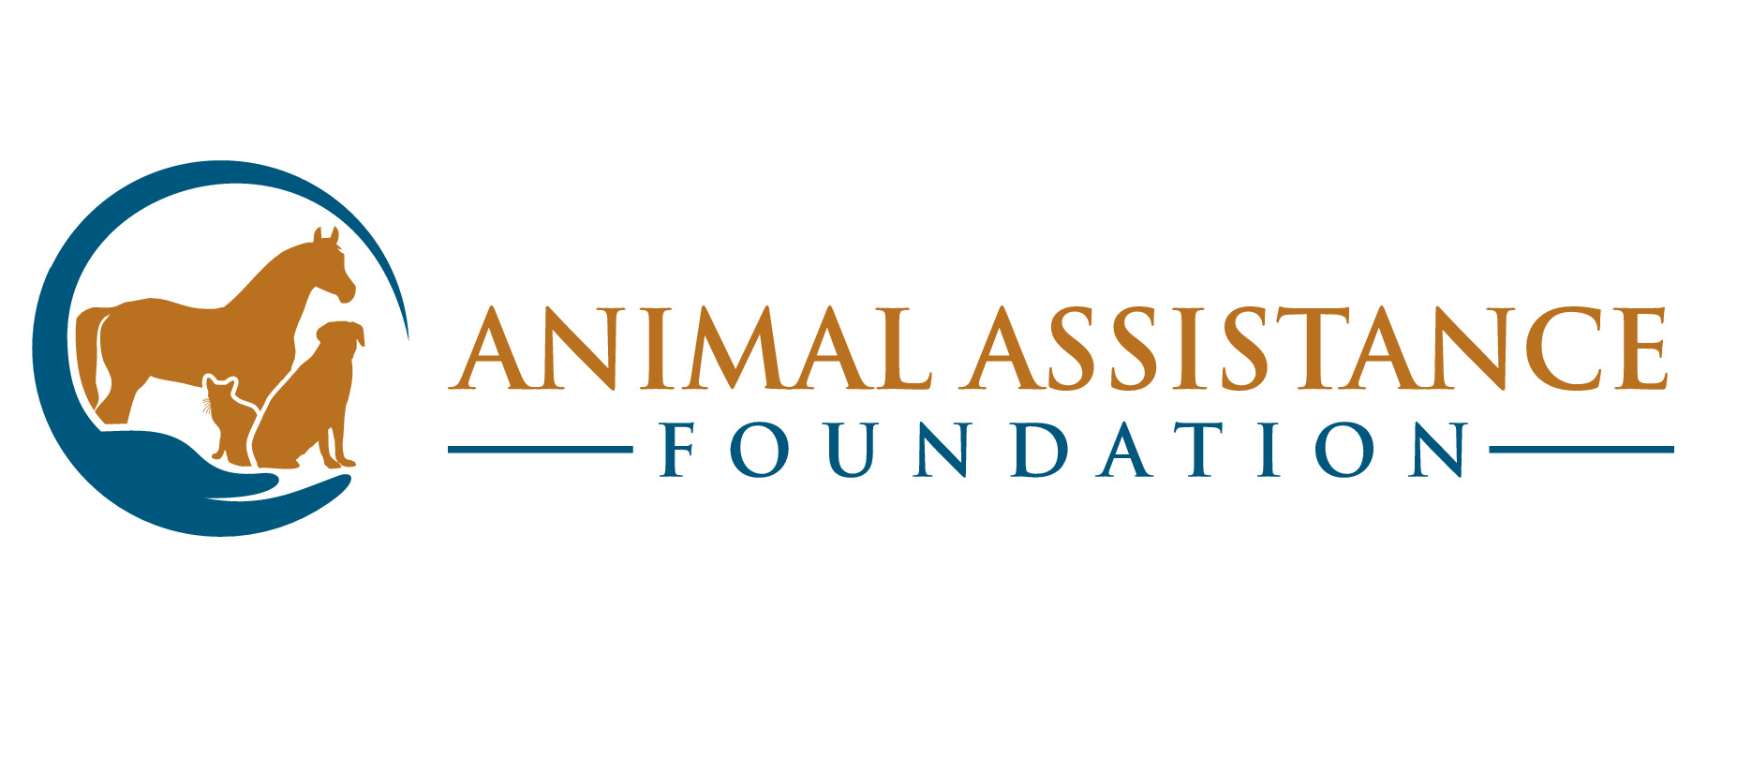 | 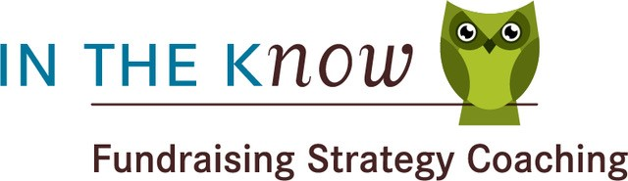  Access to learning is at the core of what we do. It’s the heart of our signature coaching service, and our motivation for sponsoring fundraising professionals like you.

