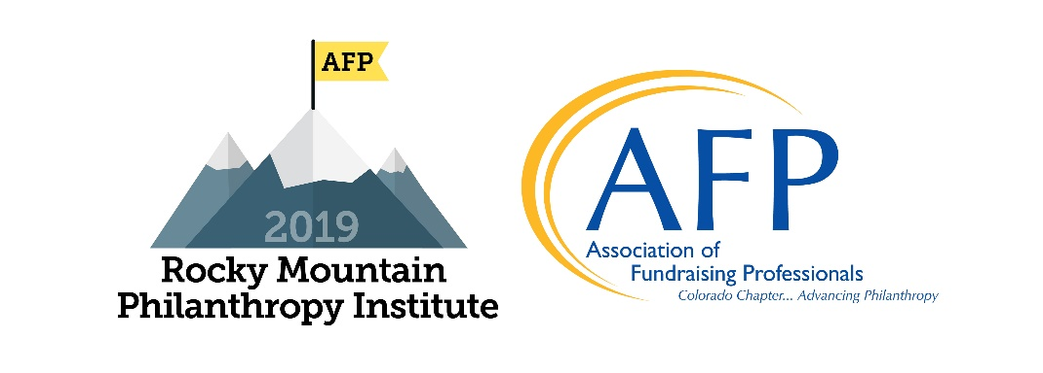
Association of Fundraising Professionals/Colorado Chapter
2019 RMPI – Creating Connections, Sept. 12-13
Scholarship Application
Education Sessions and Networking Reception
Application Deadline: July 9, 2019 - Awardees will be notified no later than August 1.
Note: If you are not awarded a scholarship, you can still register for the early bird pricing since early bird pricing ends August 9.

Scholarships are offered on a one-time basis. Individuals who have previously received an RMPI scholarship are not eligible. Scholarships are awarded as partial scholarships based on information submitted to the committee.

Your Information

Applicant’s Name: Click here to enter text.
Job Title: Click here to enter text.
Employer: Click here to enter text.
Business Address: Click here to enter text.

City: Click here to enter text. State: Click here to enter text. Zip: Click here to enter text.

Business Phone Number: Click here to enter text. Cell Phone Number: Click here to enter text.

Email Address: Click here to enter text.

1. How long have you been at your present job? Click here to enter text. Years Click here to enter text. Months

2. How long have you been in the fundraising field? Click here to enter text. Years Click here to enter text. Months

3. Are you an AFPCC member? ☐Yes ☐No

If not, please comment on why not: Click here to enter text.

Continued on next page

4. The scholarships awarded for this conference will be partial scholarships, so award winners will need to cover some part of the cost of attending. How will you pay for the uncovered portion of the cost?
☐ I will pay for it personally ☐ My organization will pay for it

☐ I will split it with my organization. ☐ Other (please comment) Click here to enter text.

5. There is a pre-conference session on Thursday, September 12. Would you be interested in attending: Better Together: Summit on Creating Connections for Colorado where we’ll openly discuss how to break down silos within and between organizations. You’ll hear success stories from leaders in the field (including Reggie Rivers and keynote speaker Vu Le) and contribute to a state-wide conversation about how to build the connections that will move the entire Colorado nonprofit sector forward.

☐ Yes
☐ No

6. Please include an additional sheet (one page maximum) to provide us with your answers to the following two questions:

A. Why do you want to attend RMPI?
B. Why do you need this scholarship?

7. Would you be willing to help us promote scholarships, as in speaking at an AFP program or writing an article for Thursday Thoughts? Click here to enter text.

- AFP is committed to diversity. Do you represent an underrepresented group? What could you add to the diversity of our conference?
Click here to enter text.

(Applicant’s Signature) (Date)

________________________________________________ _________________________________
(Supervisor’s Signature) (Date)

Please complete this form and email it by July 9, 2019. Thank you!

deann@afpcc.org
DeAnn Acosta, CFRE
Executive Director, AFP Colorado Chapter
Phone: 720.234.1050

Thank you to our Scholarship Sponsor
