2023 Award Nomination Form National Philanthropy Day in Colorado

*Please see Nomination Instructions (afpcc.org) for information on completing and submitting nominations

Nominee Information

Nominee
Name:
 | First | Last
Organization:
Address:
 | Street Address |  | Apt./Unit #

 | City | State | ZIP Code

Primary Phone: |  | Alternate Phone:

Email:

Category of Nomination (please check ONLY ONE)

☐ Lifetime Achievement
☐ Outstanding Large Business (Number of Colorado employees ________________)
☐ Outstanding Small Business (Number of Colorado employees ________________)
☐ Outstanding Foundation
☐ Outstanding Philanthropist
☐ Outstanding Professional Fundraiser
☐ Outstanding Professional Grantmaker
☐ Outstanding Service Organization
☐ Outstanding Volunteer
☐ Outstanding Volunteer Fundraiser
☐ Inspiration Award

Nominator Information

Submitted/Nominated By:
Name:
 | First | Last
Organization:
Address:
 | Street Address |  | Apt/Unit #

 | City | State | ZIP Code

Primary Phone: |  | Email:
Relationship to Nominee:

How did you hear about us?

If your nominee is not selected, would you like them to be notified that they were nominated? ☐Yes ☐No

If your nominee is selected, can we share a copy of the nomination with them? ☐Yes ☐No

Refer to the Nomination Instructions for Complete Directions

Please remember:
- Each nomination must include:
- Nomination Form
- Nomination narrative
- Two letters of support from organizations other than nominator (additional letters will not be accepted)

- The nomination deadline is Monday, July 17, 2023 at 5:00 PM (MST)
- No exceptions!
- All nominations must be complete when submitted
- If you would like feedback on your nomination from a member of the Awards & Selection Committee (not the judges) before formally submitting your nomination, please submit your draft materials by July 7 via email with a note to that effect.
- Complete nominations must be emailed to DeAnn Acosta, CFRE, deann@afpcc.org.

Thank you for supporting National Philanthropy Day in Colorado
afpcc.org
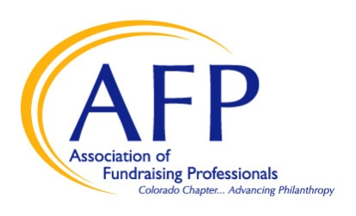

Questions? Contact DeAnn Acosta: deann@afpcc.org

