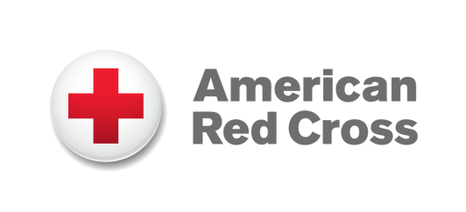

The American Red Cross depends heavily on the support of our generous donor population. We participate in many donor-focused fundraising activities including identifying, cultivating, soliciting and stewarding of top corporate and foundation partners, as well as with individual donors across the country. The funds we receive provide unrestricted support to our Chapters, helping us fulfill our mission to provide relief to victims of disaster and help people prevent, prepare and respond to emergencies in our communities.

We are currently seeking a Regional Philanthropy Officer to work in our Des Moines Chapter office.

The American Red Cross is seeking a motivated and experienced Philanthropy Officer to play an integral role in fund development for the region. Manages the organization’s individual fundraising and development activities for the region. Oversees fundraising strategies and ensures that development goals and objectives are met. Cultivates individuals for the direct purpose of soliciting funds through established or contribution events.

1. Oversee the identification, cultivation, solicitation, and stewardship of donors, data reporting and acknowledgement of specific donor funds and/or gifts in-kind.
2. Increase the organization’s fundraising capacity by developing training curricula, materials and resources for fundraising initiatives.
3. Create and implement fundraising goals, objectives and action plans to support revenue objectives with organizational short- and long-term goals.
4. Directly participate in the solicitation of funds from high-level contributors.
5. Responsible for the management of the organization's fundraising and development efforts with direct management of Divisional Relationship Managers as well as indirect management of regional development teams. Provides overall direction and management to management- and professional-level staff. Conducts strategic planning. Interfaces with executive leadership
6. Continual analysis of business plan identifying trends, successes, opportunities and learnings.

Education: 4-year college degree or equivalent combination of education and experience Marketing, Sales, Business, Category Management, Fundraising or related field.

Experience: Minimum 3 to 4 years required

Travel: Requires frequent travel within the Region. The amount will vary depending upon size and geography of region. May travel and participate in meetings and conferences throughout chapter jurisdiction, state and Red Cross system. Because the Red Cross is a disaster response organization, staff may be asked to be on 24-hour call during period of major disaster.

If this sounds like the kind of opportunity that you’ve been waiting for, please visit our website at:

https://americanredcross.wd1.myworkdayjobs.com/American_Red_Cross_Careers/job/Des-Moines-IA/Regional-Philanthropy-Officer_RC25001

The American Red Cross is a nonprofit organization that offers employees growth and development, team spirit, competitive salaries and a comprehensive benefits package. We are proud to be an Equal Opportunity/Affirmative Action Employer M/F/D/V.

