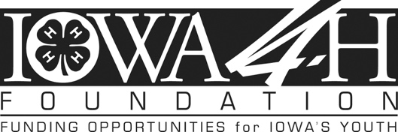

Position: Director of Leadership Gifts / Development Officer

Job Summary: Self-motivated individual with a proven track record in fundraising. This position reports to the Executive Director. Primary areas of responsibility include solicitation and stewardship of mid-level, major and planned gift donors. Full Time.

Primary Responsibilities:
- Partner with the Executive Director to prepare the annual individual fundraising plan, including revenue goals and specific measurable objectives, tactics and timetables.
- Execute fundraising plan and drive increased income from individual donors
- Build and manage a portfolio of 100 to 150 donors and donor prospects.
- Travel extensively (up to 50%, primarily in state) to establish, nurture and grow donor relationships with the end goal of proposing and closing mid-level and major gifts.
- Write donor correspondence, contact reports, proposals, and stewardship communication.
- Steward donor relationships and provide ongoing communication with donors regarding the impact of their support.
- Collaborate with County and State 4-H Staff to identify funding opportunities and understand program impact.
- Evening and weekend work may be required.

Qualifications:
Education & Work Experience
- Bachelor’s degree and three to five years professional experience in any of the following areas: major gift fundraising, non-profit work, sales, communications, or other related field.

Desired Skills & Experience
- Understanding of and commitment to, donor-centered philanthropy principles to develop and sustain relationships with individual donors
- Demonstrated ability to solicit and close major gifts
- Outstanding written and verbal communication skills to connect with donors, stakeholders and staff
- Committed work ethic and ability to work both independently and with a team
- Ability to multi-task, manage, and organize multiple initiatives
- Familiarity with using data to make fundraising decisions
- Ability to use a variety of software applications, familiarity with Raisers Edge preferred
- Creativity, patience, and a sense of humor
- Familiarly with and affinity for the 4-H Program or similar youth development organizations

Compensation: Salary range: $60,000-$70,000 commensurate with experience. Health, Dental, 401k

Special Conditions: All offers of employment, oral and written, are contingent upon the Iowa 4-H Foundation's verification of credentials and other information required by federal and state law, and may include the completion of a background check.

Application Instructions:
Submit the following items to the contact listed below:
1) Resume
2) Letter of Application/Cover Letter
3) Contact information for three references

Emily Saveraid, Executive Director: esaver@iastate.edu / 515.294.1552

For full consideration, submit application by March 1. Applications accepted until position is filled.
For more information about the Iowa 4-H Foundation, please visit us online at: www.iowa4hfoundation.org.

