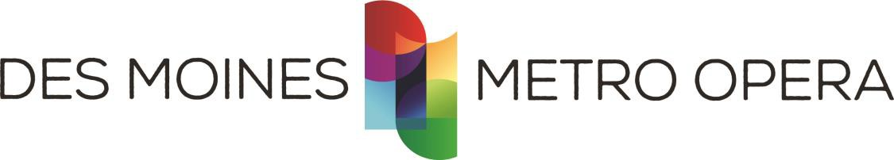

JOB TITLE: Development Manager

Reports to: Director of Advancement

Classification: Full-time, Salaried, Exempt

SUMMARY:
The Development Manager is responsible for overseeing donor acknowledgements, donor tracking, and executing a multi-medium fundraising solicitation strategy including phone calls and mailings, benefit and recognition fulfillment, with the goal of realizing revenue streams to support DMMO’s robust artistic and community programming through implementing fundraising in a cost-effective and time-efficient manner. Reporting to and in partnership with the Director of Advancement, the Development Manager will have primary responsibilities including overseeing a direct-response annual fundraising program, facilitating communications with Boards, and overseeing the public institutional giving program (government grants) in keeping with the overall mission of the Company. The ideal candidate will have a passion for arts fundraising and will focus on growth through donor communication and stewardship. This candidate will enjoy connecting with DMMO patrons and donors regularly, building new relationships, and will be organized with exceptional written and verbal communication skills.

DUTIES and RESPONSIBILITIES:
- Promote an inclusive, respectful and compassionate working environment that prioritizes the Company’s values towards equity, diversity and inclusivity.
- Gain an expert understanding of our donor database, PatronManager/Salesforce, to utilize as an essential tool to successfully execute donor retention, acquisition, and stewardship strategies.
- Act as Salesforce/Patron Manager administrator, assisting with data management needs
- Work closely with finance to reconcile monthly donation records and data
- Generate and regularly distribute fundraising metric/tracking reports to the Advancement team.
- Create and implement a detailed direct mail and digital program to include annual campaigns focused on donor retention, acquisition of new donors, re-engagement of lapsed donors, and increasing gift amounts from individual donors.
- Develop communication and stewardship opportunities throughout the program year in partnership with the Marketing, Civic Engagement, and Artistic areas.
- Develop analysis on past giving trends and program results.
- Maintain and coordinate Board communications, serving as primary contact for the Board of Directors and maintaining Board of Directors’ Handbook.
- Reliably manage public grant deadlines and reporting; prepare and submit proposals on a timely basis to the public funding sources to generate revenue.
- Prepare and maintain an annual schedule of submissions and reports due for grants with careful attention to deadlines while researching, soliciting and cultivating new streams of revenue and funding from civic, state and federal government sources.

REQUIREMENTS:
- Have passion for connecting and building relationships with people.
- Excellent donor/customer service skills and relationship management skills
- A BA is required with at least three years of non-profit fundraising experience required. Proven success in face-to-face solicitations and relationship building including experience with direct mail or membership campaigns a plus.
- Be self-motivated and an independent thinker who consistently meets deadlines, resolves conflicting priorities, and has outstanding interpersonal skills.
- Excellent organization skills and exceptional written and verbal communication.
- Extremely detail-oriented and thorough work required.
- Ability to manage multiple projects simultaneously and achieve results in a timely fashion.
- Ability to work evening and weekend events.
- Flexibility and solution-oriented focus within fast-paced and ever-changing environments and various personalities.
- Ability to maintain and work within a budget.
- Strong computer skills, including knowledge of Microsoft Excel and Word. Experience with Salesforce/PatronManager or Tessitura is a plus.
- Residency in Des Moines, IA metro area. A relocation stipend will be offered if needed.

PHYSICAL STANDARDS:
This position involves moderate work with lifting or moving of up to 30 pounds occasionally and sitting or standing for long periods of time. The position requires ability to use computer equipment, manual dexterity, and the ability to communicate verbally and in written word. This position occasionally requires long hours and a flexible work schedule in support of a performance schedule and special events.

BENEFITS:
Competitive health, life, disability, and retirement plan, and generous PTO. Salary range is $45,000-$53,000 dependent on experience and qualifications.

APPLICATION PROCESS:
Submit resume and cover letter, email or by mail to:
Des Moines Metro Opera
Attn: Tim McMillin, Director of Advancement
106 West Boston Avenue
Indianola, IA 50125
tmcmillin@dmmo.org

DEADLINE:
Applications will be accepted until the position is filled. Applicant screening process to begin immediately.

As an Equal Opportunity Employer, Des Moines Metro Opera celebrates diversity and inclusion. We do not discriminate against any employee or job applicant on the basis of race, color, religion, national origin, creed, gender identity, sexual orientation, pregnancy, disability, age, veteran status, political affiliation or philosophy. All qualified applicants are encouraged to apply.

