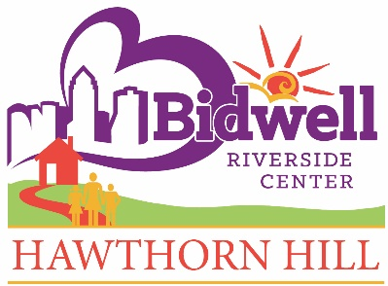
Bidwell Riverside Center/Hawthorn Hill
Development/Public Relations Director

BRC-HH (Bidwell Riverside Center and Hawthorn Hill) is hiring for a Development/Public Relations Director. The Development/Public Relations Director is responsible for designing, implementing and managing Bidwell Riverside Center’s and Hawthorn Hill’s fund development and public relations/marketing strategies. The Development/Public Relations Director will work closely with the Executive Director to achieve fundraising and communication goals.

Essential Functions:
- Develop an annual budget and plan for fundraising with specific annual goals.
- Cultivate major donors including identification of prospects and facilitating meetings and person-to-person solicitations for the Executive Director.
- Develops program to acknowledge donors and nurture continued giving.
- Research and develop grant opportunities that will assist with funding operations and projects.
- Write grant proposals in accordance with grantor standards or requirements and provides grant reporting when required.
- Plan and manage annual fundraising events.
- Create print materials, multi-media presentations to generate interest and support.
- Prepare press releases and manage media relations.
- Plan and supervise the implementation of social media tools to advance Bidwell Riverside Center’s and Hawthorn Hill’s missions and inform our supporters of opportunities to give, volunteer and advocate.
- Responsible for creation and distribution of e-communications.
- Help plan and implement capital campaigns.

Qualifications:
- Bachelor's degree from an accredited university in Communications, Marketing, Public Relations or related field. CFRE status preferred.
- Minimum three to five years progressive fundraising experience with demonstrated success.
- Thorough knowledge of fundraising practices.
- Strong communication skills, oral and written.
- Experience in grant writing and implementation, and knowledge of sources of funding.
- Events management experience.
- Ability to effectively communicate through use of written and social media.
- Capacity to prioritize and handle multiple projects.
- Ability to effectively represent Bidwell Riverside Center and Hawthorn Hill in the community and to develop rapport with funders and donors.
- Willing to work outside regular business hours, including occasional evenings and weekends.
- Current Iowa driver's license with good driving record and adequate auto liability insurance coverage.

Pay/Benefits:
Competitive pay based on experience and qualifications. Excellent benefits include PTO; health, dental, disability & life insurance; and 401(k) plan retirement program.

Working Conditions/Physical Demands:
Office environment with occasional travel both in and outside the community. Requires frequent use of computer to access information. Physical Demand level is Sedentary-Light.

Interested candidates should send cover letter, resume
and salary history to: tim@hawthorn-hill.org.

Position is open until filled.

Bidwell Riverside Center/Hawthorn Hill are Equal Opportunity employers. Personnel are chosen on basis of ability without regard to race, color, religion, sex, national origin, disability, marital status or sexual orientation, in accordance with federal and state law.

