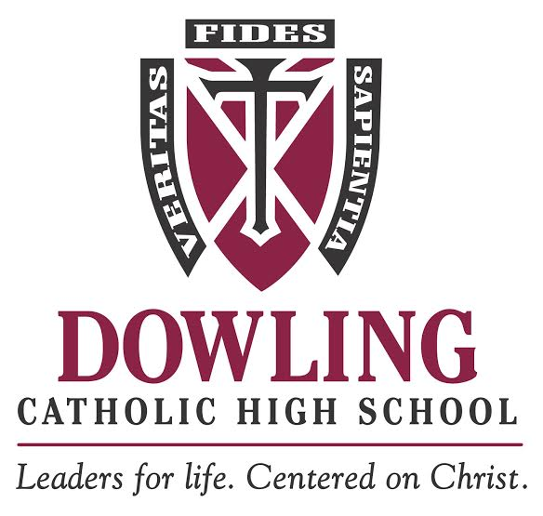

JOB DESCRIPTION

Position: Assistant Director of Advancement

Department: Advancement

Reports To: Director of Advancement

FLSA: Exempt

Position Purpose:
The Assistant Director will work with the Director of Advancement to develop strategies to raise the profile of Dowling Catholic High School in greater Des Moines. The Assistant Director will provide leadership to the Advancement team, be responsible for expanding fundraising activities, donor relations and stewardship. The Assistant Director supervises the Fundraising Coordinator.

Primary Responsibilities:
- Provide daily oversight of development operations including donor relations, gift processing and stewardship
- Work with Director of Advancement to develop and assess annual advancement plan to meet goals and objectives
- Cultivate current and new donor relationships with the intent of sustaining and increasing donor engagement and support for the school
- Develop and manage a portfolio of 75-100 donors capable of making gifts over $10,000
- Lead development and implementation of a comprehensive stewardship program for donors and prospects to annual appeal, major gifts, campaigns, special projects and planned giving
- Develop and manage a planned giving program; expand and engage Legacy Society membership
- Manage development team activities including oversight of moves management: moving donors along continuum from identification through solicitation to stewardship
- Lead pipeline development effort, utilizing prospect research
- Manage Fundraising Coordinator and annual operating fundraising activities
- Participate in special events, provide guidance and support as needed
Hiring/Education Requirements:
- Bachelor’s degree and 3-4 years of development and fundraising experience (Catholic school experience a plus K-12 or college)
- Previous professional experience raising gifts over $25K
- Previous experience leading and inspiring a team
- Knowledge of pipeline building and the ability to generate a successful process for fundraising efforts
- Successful experience in major gifts solicitation/stewardship practices/planning giving programs/event and volunteer coordination
- Strong technology skills acquired through knowledge of fundraising software and miscellaneous tools. Raizer’s Edge NXT experience a plus
- Excellent interpersonal skills
- Project research experience preferred
- Some travel required
Physical and Environmental Requirements:
- Physical requirements include sitting, talking, listening, reading, writing, and keying/finger dexterity
- Ability to lift 25 lbs
- Environmental requirements including working indoors

