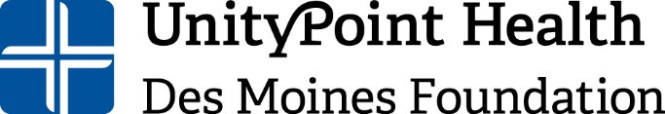

https://careers-unitypoint.icims.com/jobs/91074/job

Annual Giving Coordinator
UnityPoint Health – Des Moines Foundation

Description of Position:
This critical role develops, designs, and implements a broad range of compelling philanthropic communications, marketing materials, and donor engagement activities that engage, cultivate, and inspire annual donors and prospects giving to the Foundation.

The Annual Giving Coordinator will be responsible for helping expand our annual gift programs and provide global responsibility for the direct mail and stewardship programs for the UPH-DM Foundation. This position will report to the Director of Development & Communications, with emphasis on coordination with the Development Team.

About our Mission: Our mission is to improve the health of our communities through philanthropy, service, and volunteerism. Our vision is to develop community and financial resources necessary to support UnityPoint Health – Des Moines (UPH-DM) in providing premiere quality health care for the communities we serve, now and into the future.

Essential Functions/Responsibilities:
Direct Mail Solicitation
- Coordinate a multi-layer approach to all direct mail solicitations.
- Lead the writing and production of all direct mail solicitations, acquisition of new donors, stewardship (including donor story/department report back), email communication, social media, website, video, and the donor journal/annual report.

Annual Giving Initiatives
- Develop strategic annual gift initiatives with a focus on donor acquisition and donor retention, including but not limited to first-time donor welcome packets, donor calls for of gifts of $100 to $250, and reactivation program.
- Implement, retain, and steward donors through the Employee Giving Campaign.
- Monitor acquisition and retention data for existing and new donors to inform communication strategy.

Annual Giving Stewardship
- Develop and implement annual and mid-level giving initiatives, priorities and strategies to ultimately move annual donors ($999 and below) to major gift candidates.
- Create compelling donor stewardship materials and communications, including but not limited to stewardship and impact reports, customizable impact templates, donor recognition, giving societies, acknowledgement letters, phone call scripts, solicitation letters, proposals, donor testimonials, and e-mail updates.

Digital Media
- Implement digital media plan for donor communication and events, including video promotion, donor stories, picture previews as well as real-time social medial management.

Education & Experience:
- Bachelor’s degree; advanced degree preferred.
- A minimum of five years as a development professional or compatible experience or in a related field.
- Experience with annual gift fundraising and stewardship.
- Experience creating emotional content that generates measurable ROI.

To see full description and apply online: https://careers-unitypoint.icims.com/jobs/91074/job

Questions may be directed to:

Erin Wendt
She/Her/Hers
Sr. Director of Development & Operations
UnityPoint Health – Des Moines Foundation
1415 Woodland Avenue, Ste. E-200
Des Moines, IA 50309
515.241.6838
erin.wendt@unitypoint.org
www.unitypointfoundation.org

