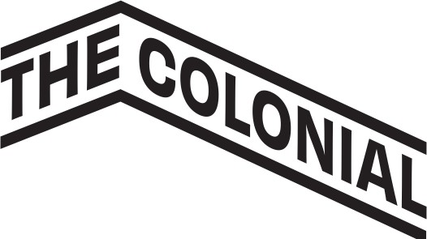

Job Title: Annual Fund & Membership Manager
Reports To: Executive Director and Development Committee Chair
Location: Keene, NH
Classification: Full-Time, Exempt
Salary: $55,000–$60,000 annually, commensurate with experience
Benefits: Health and dental insurance, paid vacation and holidays, flexible schedule (within in-person expectations), professional development opportunities, and complimentary tickets to select performances at The Colonial Theatre and SHOWROOM.

Position Overview
The Annual Fund & Membership Manager is a key member of the development team at The Colonial Theatre and SHOWROOM, responsible for growing and stewarding our base of individual donors, corporate sponsors, and members. This role focuses on the planning and execution of annual fund campaigns, cultivating and retaining members and small business sponsors, and maintaining donor and membership data within our CRM system, AudienceView.

This is an in-person role best suited for someone who is detail-oriented, personable, and thrives in a collaborative, community-centered nonprofit environment. The position requires the ability to manage donor communications, analyze data for trends and reporting, and support the larger fundraising ecosystem for The Colonial Theatre and SHOWROOM.

Key Responsibilities
1. Annual Fund Campaigns
- Plan and execute annual fund strategies using direct mail, email, and digital appeals.
- Create segmented donor lists and personalized communications for annual fundraising.
- Collaborate with marketing for consistent messaging and branding.
2. Membership and Sponsorship Stewardship
- Manage membership lifecycle: renewals, upgrades, acquisition.
- Cultivate and steward small business sponsors and entry-level donors.
- Maintain member/sponsor acknowledgment and benefits processes.
3. CRM and Data Management
- Maintain donor and member records in AudienceView (CRM).
- Produce regular donor and campaign reports for internal use.
- Oversee donation acknowledgment letters and receipt generation.
4. Donor Stewardship and Engagement
- Support cultivation and stewardship strategies for donor retention and upgrades.
- Coordinate small donor-focused events and recognition efforts.
5. Collaboration and Team Support
- Collaborate closely with the Executive Director and Development Committee.
- Provide administrative support to fundraising efforts and events as needed.

Qualifications & Skills
- Minimum of 1 year of experience in nonprofit fundraising, membership, or development.
- Familiarity with CRM systems; preference for candidates with AudienceView experience.
- Strong written and verbal communication skills.
- Highly organized with attention to detail and ability to manage multiple priorities.
- Comfort with analyzing data and preparing reports.
- Personable, collaborative, and eager to contribute to a team-oriented culture.

To Apply
Please submit a resume and cover letter to hiring@thecolonial.org. Applications will be reviewed on a rolling basis until the position is filled.

