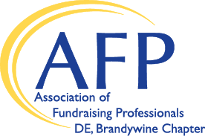
2023 Mentee Application

Name Click here to enter text.
Organization Click here to enter text. Position Click here to enter text.
Address Click here to enter text.
City Click here to enter text. State Choose an item. ZIP Click here to enter text.
Email Click here to enter text. Phone Click here to enter text.
Years as a professional fundraiser Click here to enter text.
Please check up to three options that best reflect your areas of interest in receiving mentorship:

☐ Annual giving
☐ Board development/relations
☐ Capital campaigns
☐ Career planning
☐ Corporate giving
☐ Database management
☐ Donor stewardship
☐ Finance/budgets
☐ Foundation giving
☐ Grantwriting
☐ Major gifts
☐ Marketing/media relations
☐ Operations/administration
☐ Planned giving
☐ Prospect research
☐ Special events
☐ Staff management
☐ Strategic planning
☐ Volunteer management
☐ Social media

Please indicate the type(s) of organizations with which you have had the most experience:

☐ Arts/culture
☐ Conservation/environment
☐ Consulting firm
☐ Education
☐ Health
☐ Historical
☐ Human Services
☐ Religion
☐ Youth
☐ Other Click here to enter text.

What do you hope to gain as a participant in this mentoring program? Click here to enter text.

Please indicate your preferred time of day and day(s) for meetings. Click here to enter text.

What geographic area(s) do you prefer for meetings? Click here to enter text.

Please include a resume/bio with your application and submit via email to chapter@afpbrandywine.org by Friday, February 3, 2023.

