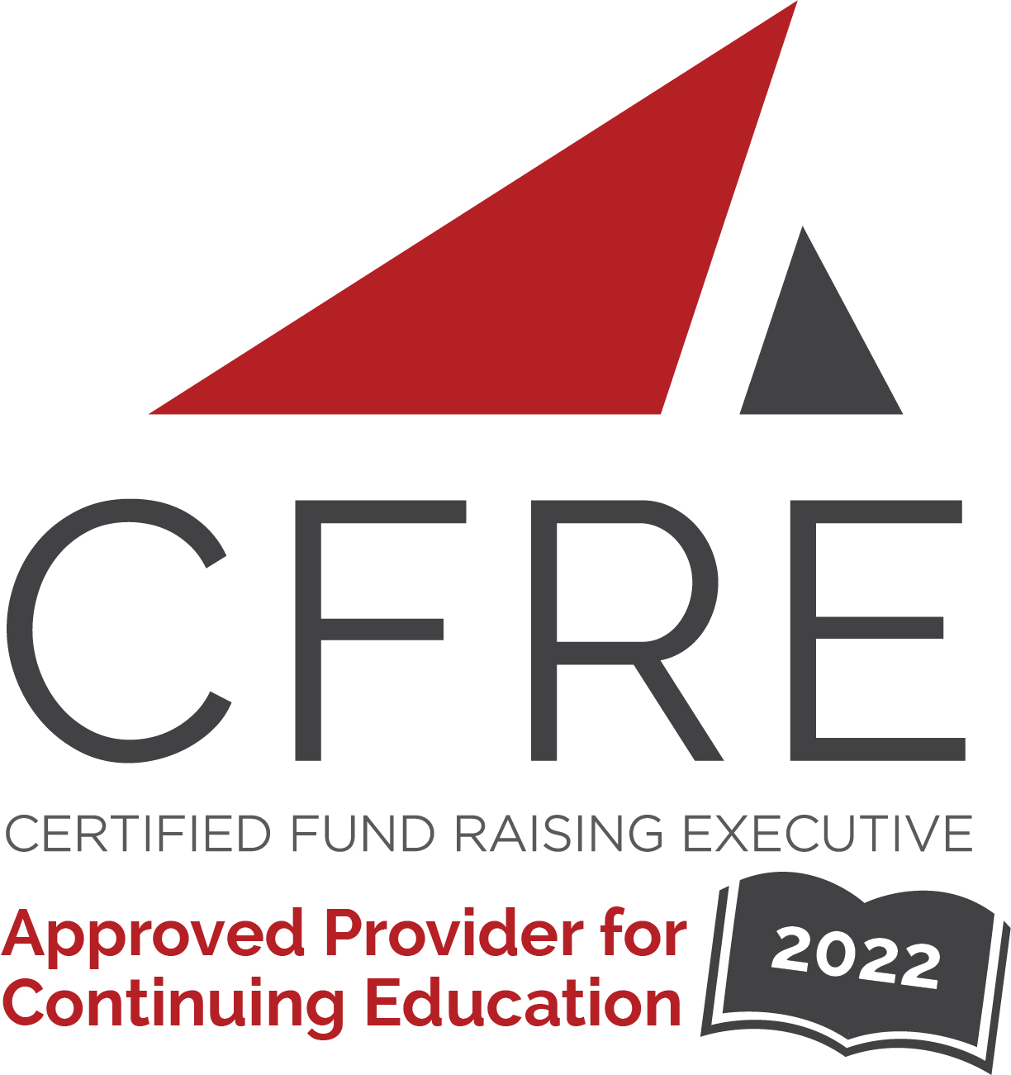  CFRE International has developed this form as a way for you to quickly track (and keep in your files!) the continuing education sessions you have attended. Simply check the boxes next to the sessions you attended. At the end of the conference, add up the total number of hours. Keep this sheet and you will be ready to complete your application form. All of the session slots listed are eligible for continuing education points on your CFRE application for initial certification and/or recertification. Sessions not listed here are not eligible for points. |  | CONTINUING EDUCATION POINTS TRACKER

Activity Organizer: - AFP New Jersey Chapter
Title of Activity: - AFP-NJ Chapter 42nd Annual Conference on Philanthropy
Names of Presenter(s): - Various
Dates and Location: - 17 November, 2022 – Bridgewater, NJ USA

Date: 17 November, 2022
Session 1: 9:00am – 10:00am (1 pt)
- “Yes, and…” Improving Communication & Leadership Through Improv

Date: 17 November, 2022
Session 2: 10:00am – 10:45am (.75 pts)
- Planned Giving
- Board Development
- Young Professionals
- Mid-Level Donors
- Non-Fundraising Professionals

Date: 17 November, 2022
Session 3: 11:15am – 12:15pm (1 pt)
- Foxy Ideas for Donor Retention
- Playing the Mental Game: Money Mindset and Fundraising Success
- Holistic Success: Annual and Endowment Integration
- Rage Giving: Leveraging Public Impulse for Organizational Sustainability
- Sustaining Fundraising in a Changing Economy
Date: 17 November, 2022
Session 5: 2:15pm – 3:15pm (1 pt)
- 3 Steps to Fund the Big Ideas in Your Strategic Plan Without Adding More Events, Grant Applications, or Appeals
- You Won’t Get Corporate Dollars the Way You Think You Will
- DE&I In a Nutshell
- [Session Title]

Date: 17 November, 2022
Session 6: 3:15pm – 4:00pm (.75 pts)
- Stewardship & Retention
- Major Gifts
- Monthly Giving
- Cryptocurrency
- Prospect Research
- Events

Total number of points attained:

