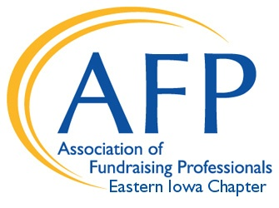

Association of Fundraising Professionals
Eastern Iowa Chapter

MEMBERSHIP SCHOLARSHIP GRANT APPLICATION
www.afpeasterniowa.org

The membership scholarship is for fundraising professionals new or not previously a member of AFP.

Submit completed typed application to Patti Kunz by November 20, 2020 at patti.kunz10@gmail.com.

Please type all answers.

DATE_________________________

NAME__________________________________________________________________

TITLE/POSITION________________________________________________________

EMPLOYER_____________________________________PHONE_________________

EMPLOYER ADDRESS___________________________________________________

_______________________________________________________________________

FAX___________________________ E-MAIL_________________________________

LENGTH OF TIME IN CURRENT POSITION_________________________________

Please list at least one reference and a contact phone number (other than employer listed above).

The goal of the Membership Grant is to introduce you and your organization to the many benefits of AFP membership. How will membership impact your work?

Statement of organization’s mission:

What is the annual operating budget for organization?

Prior development achievement/experience:

Please provide a description of your duties and how much time you spend on fundraising.

List the training opportunities you have with your agency’s budget for the current year:

Can you or your organization continue AFP membership beyond the one-year grant period and how would that be done?

Please circle the membership category listed below in which you would qualify if chosen to receive a scholarship? (Membership categories and description may be viewed at www.afpnet.org/Join)

Professional Young Professional (under 30) Retired

Associate Collegiate Business

Non-Profit – Large Organization Non-Profit – Small Organization

Please include ways in which you can contribute or become involved in AFP, if chosen as a scholarship recipient?

Please provide the name and address of your local newspaper. If you receive the scholarship, we would like to submit a press release to your local media.

Completed applications are due by November 6, 2020 and should be emailed to:
EIAFP Scholarship Committee Chair, Patti Kunz – patti.kunz10@gmail.com.

The AFP Eastern Iowa scholarship will cover the cost of the national dues that typically range from $120 - $280. The scholarship recipient or their organization may be responsible for the local chapter dues in the amount of $50.

AFP Eastern Iowa is a volunteer-run organization and there is an expectation that scholarship recipients will participate on some volunteer level for the organization. This may include joining a committee or volunteering for a chapter event such as the National Philanthropy Day luncheon.

