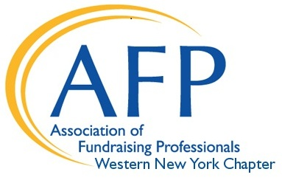
AFP Western New York Chapter
2019 Mentoring Partnership Program

Application Deadline: April 24, 2019

Name: __________________________________________________ Title: ___________________________________________

Organization: _____________________________________________________________________________________________

Daytime Work Address:___________________________________________________________________________________

Phone: (M) (O) __________________________________ Email: __________________________________________________

I would like to be a: ☐ Mentor ☐ Mentee

- How many years have you worked in the field? ____________

- How many people are in the development department where you work?

☐ Small (< 3) ☐ Medium (3-10) ☐ Large (10+)

- Please list goals to accomplish with your partnership match: (feel free to attach additional comments)
____________________________________________________________________________________________________
______________________________________________________________________________________
______________________________________________________________________________________
______________________________________________________________________________________

- Please indicate your areas of focus/interest

☐ Annual Giving ☐ Board Relations & Training ☐ Capital Campaigns
☐ Career Development ☐ Communications ☐ Consulting
☐ Corporate Relations/Sponsorships ☐ Direct Mail ☐ Donor Development
☐ Ethics ☐ Foundation Relations ☐ Grant Writing
☐ Major Gifts – Individuals ☐ Management of Staff ☐ Marketing/Public Relations
☐ Planned Giving ☐ Portfolio Management ☐ Proposal Writing
☐ Prospect Research ☐ Special Events ☐ Stewardship (Donor Recognition)
☐ Strategic Planning ☐ Telemarketing ☐ Volunteer Management
☐ Other: ______________________________________________________________________________________________

- What is your preferred method of communication for your mentoring relationship?

☐Face-to-face ☐Telephone ☐Email
(Please try not to conduct your
entire relationship via email)

I am aware that the time commitment is one year. I understand that some of the information shared by my mentor/mentee about their organization may be confidential in nature, and I will maintain confidentiality.

Signature: _________________________________________________________________________ Date: ___________________

Please return this form to AFP WNY Chapter Manager by Friday, April 24th, 2019.
afpwny@afpwnychapter.org – Fax: 716-887-2770 or PO Box 535, Buffalo, NY 14209

