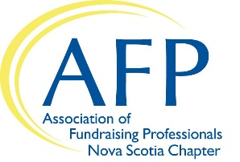

AFP Nova Scotia Mentor Application

AFP Nova Scotia is delighted that you are interested in being a mentor. This program will provide new fundraisers with a supportive environment that facilitates learning and knowledge exchange. Mentoring is a one year commitment with a six month review with the Mentoring Coordinator to ensure the match is suitable for both you and your apprentice.

Thank you for doing your part to grow the capacity of our sector in Nova Scotia.

Contact Info
Title
Name
Organization
Position
Address
City |  | Prov |  | Postal
Phone
Email

Are you willing to make time to meet with your mentor for one hour per month (preferably face to face)?
Yes No

How many years have you been in fundraising?

Briefly describe your educational and employment history.

Sector of Fundraising
Your apprentice might be interested in learning more about a certain area of fundraising and/or specific skill from their mentor. Please check the fundraising sectors and skills you are interested in mentoring:
Annual Giving
Planned Giving
Direct Mail
Major Gifts
Events
Donor Stewardship
Other:

Fundraising Skills
Multitasking
Public speaking/presentations
Problem solving
Communication skills
Leadership
Team work
Other skills:

What do you hope to get out of participating in this program?

What are your preferences regarding a match?

References

Please provide us one reference (professional or personal) that we can contact:

Name
Relationship
Phone
Email

By submitting this application, you agree to following terms:

I am aware that the time commitment is for one year. I understand that some of the information that will be shared by my mentor about his/her organization can be confidential in nature and I will respect this fact. I understand that the Mentoring Committee has the authority to make the decision as to whether or not I will be accepted into the AFP Nova Scotia Mentor Partnership Program.
Check here to agree

Next steps
After completing this online application form, our Mentoring Coordinator will contact you with a match. Thank you for your willingness to offer your time and expertise to other fundraisers! Please do not hesitate to contact us at lisa.doucette@dal.ca if you have any questions.

