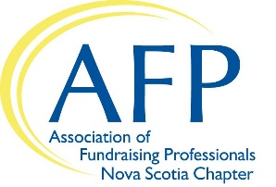

AFP Nova Scotia Mentee Application

AFP Nova Scotia is delighted that you are interested or mentorship program. This is a free program that is offered to members of AFP Nova Scotia and you are encouraged to take full advantage of this unique opportunity. Once you are matched to your mentor, it will be your responsibility to reach out to your mentor and set up at least one meeting per month. Please provide your mentor with a meeting agenda in advance to allow him/her to prepare for each meeting.

Relationships are matched for a period of one year with a three-month check in by the Mentoring Coordinator to ensure the match is the right one. Please feel out the below application. We will be in touch with you as soon as a successful match has been made.

Contact Info
Title
Name
Organization
Position
Address
City |  | Prov |  | Postal
Phone
Email

Are you willing to make time to meet with your mentor for one hour per month (preferably face to face)?
Yes No
How many years have you been in fundraising?

Briefly describe your educational and employment history.
Sector of Fundraising
Is there a particular area of fundraising that you wish to learn more about? If so, please check all that apply.
Annual Giving
Planned Giving
Direct Mail
Major Gifts
Events
Donor Stewardship
Other:

Please indicate three measurable goals you would like to accomplish with assistance of a mentor:

What do you hope to get out of participating in this program?

What are your preferences regarding a match?

By submitting this application, you agree to following terms:

I am aware that the time commitment is for one year. I understand that some of the information that will be shared by my mentor about his/her organization can be confidential in nature and I will respect this fact. I understand that the Mentoring Committee has the authority to make the decision as to whether or not I will be accepted into the AFP Nova Scotia Mentor Partnership Program.
Check here to agree

Next steps:
After completing this online application form, our Mentoring Coordinator will contact you with a match. Please do not hesitate to contact us at lisa.doucette@dal.ca if you have any questions.

