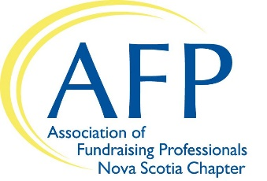
AFP Foundation for Philanthropy
2020 Chamberlain Scholarship Program
Nova Scotia Chapter

Deadline: Email this completed form by October 18, 2019 by 5:00pm
to AFPNovaScotia@gmail.com

The AFP Foundation for Philanthropy is proud to offer the Chamberlain Scholarship Program for the AFP International Conference on Fundraising. This program is designed to help individuals serving nonprofit organizations develop their knowledge and skills in fundraising. *Please see additional details notes on page two.

Personal Information
Applicant’s Name
Are you a member of AFP? | Yes | If yes, your Membership Number:
Job Title
Employer
Business Address

Website URL
Your Work # |  |  | Your Cell #
Email Address:

Supervisor’s Signature indicating their agreement to your possible attendance at this conference

___________________________________________________ Phone number:
(or signature of your organization’s Board Chair)

Background Information
Years in the Profession
Previous Training in Fundraising (Please list some courses, seminars, conferences you’ve had an opportunity to attend)
A Professional Reference (Other than present employer):

Reference’s Phone: |  | Reference’s Email:

Please provide a details and explain why and how:
A.) your organization would benefit from your attendance at the AFP International Conference (ICON) and
B.) how you professional and/or personally would benefit.

Declaration: I am employed as a full-time fundraising professional or spend at least fifty percent of my time fundraising for my employer. I have never attended an NSFRE/AFP International Conference on Fundraising and understand that only one individual from my local organization can be selected.

__________________________________________________ ______________________________
(Applicant’s Signature) (Date)

Thank you for applying for this year’s Chamberlain Scholarship. You will be contacted by October 30, 2019, should you be the successful candidate.

If you have questions, please contact:
Daphne Carter, AFP-NS Chapter President
902.425.7770 ext 259
dcarter@pier21.ca

*Please Note:
- Once selected, Chamberlain Scholars are responsible for registering online for ICON by following instructions and using a special discount code provided via a congratulatory email from AFP Global Head Quarters in mid-November.
- Scholars are responsible for making their own travel and lodging arrangements and cover those costs.
- Chamberlain Scholars who had already registered before they were named a Chamberlain Scholar are required to request a refund in writing.
- Scholars are responsible for the $10 USD processing fee at the time of registration.

