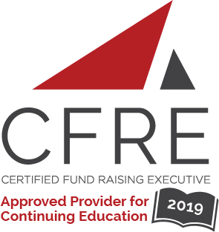  CFRE International has developed this form as a way for you to quickly track (and keep in your files!) the continuing education sessions you have attended. Simply check the boxes next to the sessions you attended. At the end of the conference, add up the total number of hours. Keep this sheet and you will be ready to complete your application form. All of the session slots listed are eligible for continuing education points on your CFRE application for initial certification and/or recertification. Sessions not listed here are not eligible for points. |  | CONTINUING EDUCATION POINTS TRACKER

Activity Organizer: - AFP Nova Scotia Chapter
Title of Activity: - Maritime Fundraising Conference
Names of Presenter(s): - Various
Dates and Location: - June 3 – 4, 2019, Halifax, Nova Scotia

Date: Monday, June 3, 2019
Session 1: 10:30 [am] – 12:00 [pm] (1.5 pts)
- [Micro Campaigns are a Big Deal]
- [The Time is Now – Planned Giving – A Candid Coversation]
- [Difficult Conversations Simplified]
- [Developing Communications for Your Nonprofit or Charity]

Date: Monday, June 3, 2019
Session 2: 1:30 [pm] – 3:00 [pm] (1.5 pts)
- [The Essence of Generosity]
- [Goals Gone Wild]
- [Why Charities Eat Their Young & How to Avoid Being Their Next Meal]

Date: Tuesday, June 4, 2019
Session 1: 10:15 [am] – 11:15 [am] (1 pt)
- [Money In the Middle How to Get a Thicker Mid-Section & Why You Should Want One]
- [Out of the Vortex: Blended Gifts]
- [Using Trends to Improve Your Fundraising Results]
- [Exercising Your Muscle]

Date: Tuesday, June 4, 2019
Session 2: 11:30 [am] – 12:30 [pm] (1 pt)
- [How to Get Your Board to Help with Fundraising]
- [From Data to $]
- [One Size Fits None: The Campaign of the Future]
- [How to Become a CFRE]

Date: Tuesday, June 4, 2019
Session 3: 2:45 [pm] – 4:00 [pm] (1.25 pts)
- [12 Strategies for Visionary Leaders]
- [Social Media in 2019: Where Charities Should be Putting Their Focus]
- [The Next Generation of Giving]

Total number of points attained:

__________

