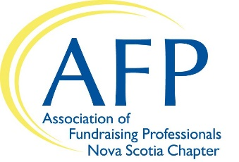
AFP Foundation for Philanthropy
2019 Chamberlain Scholarship Program
Nova Scotia Chapter

Deadline: Email this completed form by October 19, 2018 by 5:00pm
to AFPNovaScotia@gmail.com

The AFP Foundation for Philanthropy is proud to offer the Chamberlain Scholarship Program for the AFP International Conference on Fundraising. This program is designed to help individuals serving nonprofit organizations develop their knowledge and skills in fundraising.

Personal Information
Applicant’s Name
Are you a member of AFP? |  | If yes, your Membership Number:
Job Title
Employer
Business Address

Website URL
Your Work # |  |  | Your Cell #
Email Address:

Supervisor’s Signature indicating their agreement to your possible attendance at this conference

___________________________________________________ Phone number:
(or signature of your organization’s Board Member)

Background Information
Years in the Profession
Previous Training in Fundraising (Please list some courses, seminars, conferences attended)
A Professional Reference (Other than present employer):

Reference’s Phone: |  | Reference’s Email:

Should you be the selected Scholarship Recipient, please explain why and how you and your organization would benefit from attending the AFP International Conference: (up to 250 words)

Declaration: I am employed as a full-time fundraising professional or spend at least fifty percent of my time fundraising for my employer. I have never attended an NSFRE/AFP International Conference on Fundraising and understand that only one individual from my local organization can be selected.

Further, if selected as the 2018 Chamberlain Scholar for the AFP Nova Scotia Chapter, I understand and agree to the following: I am responsible for my own Conference registration with instructions/award information from International Head Quarters (IHQ) and $10.00 processing fee and travel and lodging expenses. I am also responsible for completing an online evaluation of my experience at the 2019 AFP International Fundraising Conference (issued by IHQ).*

__________________________________________________ ___________________________
(Applicant’s Signature) (Date)

Thank you for applying for this year’s Chamberlain Scholarship. You will be contacted before October 29, 2018, should you be the successful candidate.

If you have questions, please contact:
Daphne Carter, AFP-NS Chapter President
902.425.7770 ext 259
dcarter@pier21.ca

*Please Note:
Chamberlain Scholars are responsible for registering themselves online for the Conference by using a special discount code that will be provided via email from IHQ mid-November. Scholars are responsible for making their own travel and lodging arrangements. Chamberlain Scholars who had already registered before they were named a Chamberlain Scholar are required to request a refund in writing. Instructions will be provided in the congratulatory email. Scholars will be refunded all but $10.00 of the amount they paid for registration.

