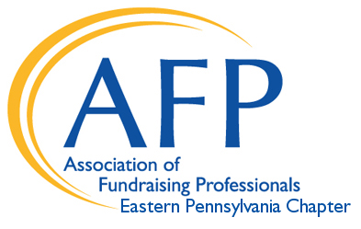
2022 Request for Proposal Application

Presentation Type: | Keynote Speaker |  |  | Workshop Presenter
Speaker Name/s:
Contact Information: | Phone: |  | E-mail:
 | Website: |  | Social:
Presenter Biography:  *Attach bio if more  space is needed | Degrees/Certifications:
 | Employer/Affiliations:
Session Title:
*If multiple submit menu as attachment
Session Description:
(150 words max)
To be used for promotional material
Target Audience:  Designate defined audience in “other” category i.e. small shops, major gifts, executive directors, etc. | Fundamentals  (1-3 years) | Intermediate (4-7 years) |  |  | Advanced (8+ years) | Other:
Session Deliverables,
Learning Expectations:
Please select preferred presentation quarter | January- March, 2022 | April- May, 2022 |  |  | June-August,  2022 | September -December, 2022
Keynote only*  Please share information and submit sample of presentations you have done. | In person ___  Virtual ___  Both ___ | Venue or  Audience: |  |  | Date/s: | Comments:
Presentation Preferences: | In person: Y/N  Virtual: Y/N | Permission to record session for future use:  Yes/No |  |  | Special requirements:
Fees: | Speaker fee: $___________ Other fees: $____________  Explain other: ____________________________________
Sponsor Opportunities: | Please indicate interest in learning more about:  Sponsorship: _____ Program Ad: _____ Vendor/Exhibitor: _____

Questions and completed proposals must be submitted via e-mail: director@afpglv.org
Applications are accepted year-round and reviewed quarterly
Presentation Period | Proposal Deadline
January -March, 2022 | December 15, 2021
April – May, 2022 | January 31, 2022
June -August, 2022 | March 31, 2022
September – December, 2022 | June 30, 2022

- Presenters are expected to promote on LinkedIn with the registration link (to be provided).
- Consultants are encouraged to co-present with a professional from the nonprofit sector.
- Presentation slides and handouts must be provided 3 weeks in advance of confirmed session date.

