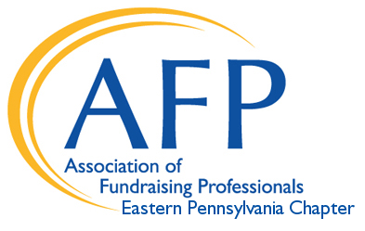
2022 Education Program
CALL FOR PROPOSALS

The Association of Fundraising Professionals - Eastern Pennsylvania Chapter (AFP-EPA) is seeking industry professionals to present their ideas, knowledge, and expertise. We are now accepting proposals for our 2022 educational programing.

As we continue to monitor the COVID-19 environment we plan to hold virtual and in-person educational programing. Tracks will include monthly workshop sessions, keynote speakers, and workshops for Lehigh Valley Philanthropy Institute in May 2022. Our chapter draws development and non-profit professionals and volunteers from the Greater Lehigh Valley, including Harrisburg, Poconos, western New Jersey, and northern and western Philadelphia suburbs.

Workshop sessions are limited to 50 minutes and should target specific audiences to educate professionals across fundamental, intermediate and advanced career levels. Please submit the attached form as completely and accurately as possible to ensure your proposal receives full consideration. We encourage attaching a menu of topics for consideration and applicable supporting materials.

Topics covering best practices in fundraising techniques, innovation, research, and career development will be selected on the following criteria:
- Originality of the presentation material.
- New approaches to current and emerging issues.
- Significance and depth of content.
- The professional experience and background of the presenter(s).

Please submit questions and completed proposals to: director@afpglv.org
Applications are accepted year-round and reviewed quarterly

- Lehigh Valley Philanthropy Institute: (We plan to host this event in-person and virtually).

Presentation Period | Proposal Deadline
January -March, 2022 | December 15, 2021
April – June, 2022 | January 31st, 2022
July -September, 2022 | March 31, 2022
October – December, 2022 | June 30, 2022

We thank you for your interest in presenting for our chapter’s
2022 educational programming!

