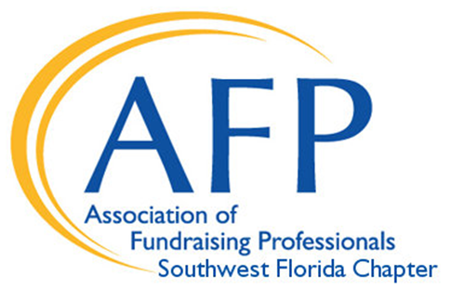

Our 2026 National Philanthropy Day
Honoree Submission form
Deadline September 30

____ Volunteer ____ Corporate ____ Foundation

____ Individual ____ Couple ____ Youth

Honoree Name: ______________________________________________________________________

Honoree Organization: __________________________________________________________

All Honorees will be recognized in pre-event PowerPoint, and program book and will receive a certificate of appreciation,.

Please include a short paragraph (90 words), single-spaced, along with a
hi-res (png preferred) picture of your honoree, by September 30 to kim.afpswfl@gmail.com

