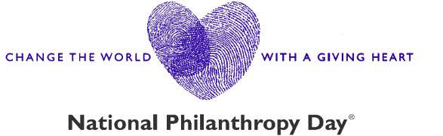

2026 Outstanding Youth in Philanthropy Nomination Questions

Philanthropic contributions to charitable causes can be made at almost any age.

This award can be presented to a youth, ages 5-23 or a group of youth who have demonstrated remarkable volunteer and/or financial support in backing of a charitable cause(s) or organization(s) in the Fort Worth metro area.

Below are the questions we ask about your nominee (the actual form includes fields for you and your nominee’s names, phone numbers, email addresses, and other details). We recommend preparing your responses in advance before starting the form, as there is no option to save a draft and return to it later.

- Tell us why you think this nominee is an exceptional example of this award. (Minimum 150 Words)
- Tell us how this nominee has participated in philanthropy through gifts of their time, talent, and treasure. (Minimum 150 Words)
- How has this nominee inspired and motivated other community members to participate in philanthropy? (Minimum 100 Words)
- What else would you like us to know about this nominee? (No Word Minimum)

Additionally, you will have the option to upload any supporting documents you would like to include.

**Use this form as a guide to help collect your thoughts, but be sure to submit your completed nominations through our online portal at http://npd.afpfortworth.com.

