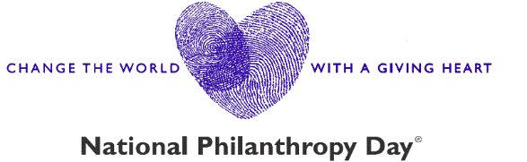

2026 Outstanding Advisor Nomination Questions

Professional advisors and gift planners play a key role in connecting individuals to community needs by helping them meet their personal charitable giving goals.

Candidates should support philanthropy in their work by facilitating significant gifts to Fort Worth metro area charities as well as personally by giving time, talent, charitable contributions and leadership among fellow professionals. Eligibility is limited to candidates representing high professional standards in one of the following fields: accounting, banking, financial planning, insurance, investment services, law or gift planning for nonprofits.

Below are the questions we ask about your nominee (the actual form includes fields for you and your nominee’s names, phone numbers, email addresses, and other details). We recommend preparing your responses in advance before starting the form, as there is no option to save a draft and return to it later.

- Tell us why you think this nominee is an exceptional example of this award. (Minimum 200 Words)
- Tell us how the nominee supports philanthropy in their work by facilitating significant gifts to Fort Worth metro area charities, as well as personally by giving time, talent, charitable contributions and leadership among fellow professionals. (Minimum 150 Words)
- How has this nominee inspired and motivated other community members to participate in philanthropy? (Minimum 150 Words)
- What else would you like us to know about this nominee? (No Word Minimum)

Additionally, you will have the option to upload any supporting documents you would like to include.

**Use this form as a guide to help collect your thoughts, but be sure to submit your completed nominations through our online portal at http://npd.afpfortworth.com.

