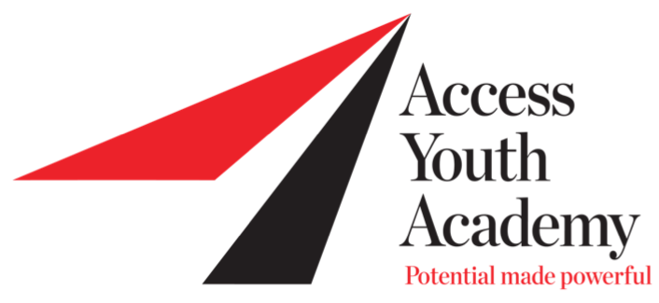

DEVELOPMENT ASSOCIATE
Access Youth Academy is an academic enrichment program based in San Diego with an operating budget of over $800,000.
This full-time position reports to the organizations Executive Director and is responsible for leading a multifaceted fundraising approach, which obtains funds from both public and private sources. As a member of the senior management team involved in setting the direction of the overall organization, the Development Director will be committed to Access Youth Academy’s mission and be a key leader in sharing and promoting the work, needs and success of the organization with donors, volunteers, and community members.
The ideal candidate will be positive and adaptable, someone who asks great questions and wants to take the organization to the next level, which involves the construction of a new Squash & Learning Facility in South East San Diego. They will also be enthusiastic about transforming young lives through education and narrowing the inequality of opportunity.
Donor Identification, Cultivation, Tracking, Correspondence & Recognition
- Draft and execute a robust fundraising plan to ensure financial goals are met
- Identify and solicit new donors to support the Access mission
- Assist and collaborate with the Executive Director on all fundraising campaigns including an upcoming capital campaign
- Draft and execute a fundraising plan to ensure financial goals are met
- Maintain and develop the effectiveness of current donor database
- Compose solicitation and cultivation letters to donors and prospects
- Prepare acknowledgement letters for all gifts
- Working with donors to ensure gifts are stewarded correctly, and ultimately renewed/upgraded
Grant Identification, Research & Proposal Preparation
- Research, writing, and compilation of grant proposals
- Identify and solicit new grant opportunities that align with the mission and goals of the organization
- Produce follow up reports and grant tracking throughout the calendar year
Special Events & Projects
- Work with key Access staff to plan and execute yearly events including a large scale annual gala in the Fall
- Support Program staff on an as needed basis

PR
- Produce monthly newsletter and contribute to social media strategy
- Draft media releases highlighting student and organizational success and pitch to local publications
- Create timely blog posts to ensure website content remains current and relevant.
Education, Skills and Experience

- Bachelors degree
- A minimum of 3-5 years in a nonprofit fundraising role.
- A progressive history of success with grant requests, event sponsorship, and expanding/diversifying revenues and donor bases.
- Excellent writing and editing skills including letters to donors, outreach materials, e-mail campaigns, twitter, etc.
- Experience and ability to work with all types of constituents such as donors, volunteers, board members, community and business leaders, government officials and others.
- Ability to work independently, demonstrate initiative, and to complete and report on assignments.
- Proficiency with Mac desirable.
- Ability to pay attention to detail and also remain oriented to the "big picture".

Access Youth Academy is an equal opportunity employer and does not discriminate against persons on the basis of race, religion, national origin, sexual orientation, gender identity and expression, marital status, age, disability, pregnancy, medical condition or covered veteran status.

Salary Range: commensurable with experience.

How to Apply: Please send a cover letter together with your resume and cover letter to Renato Paiva, Executive Director: renato@accessyouthacademy.org

