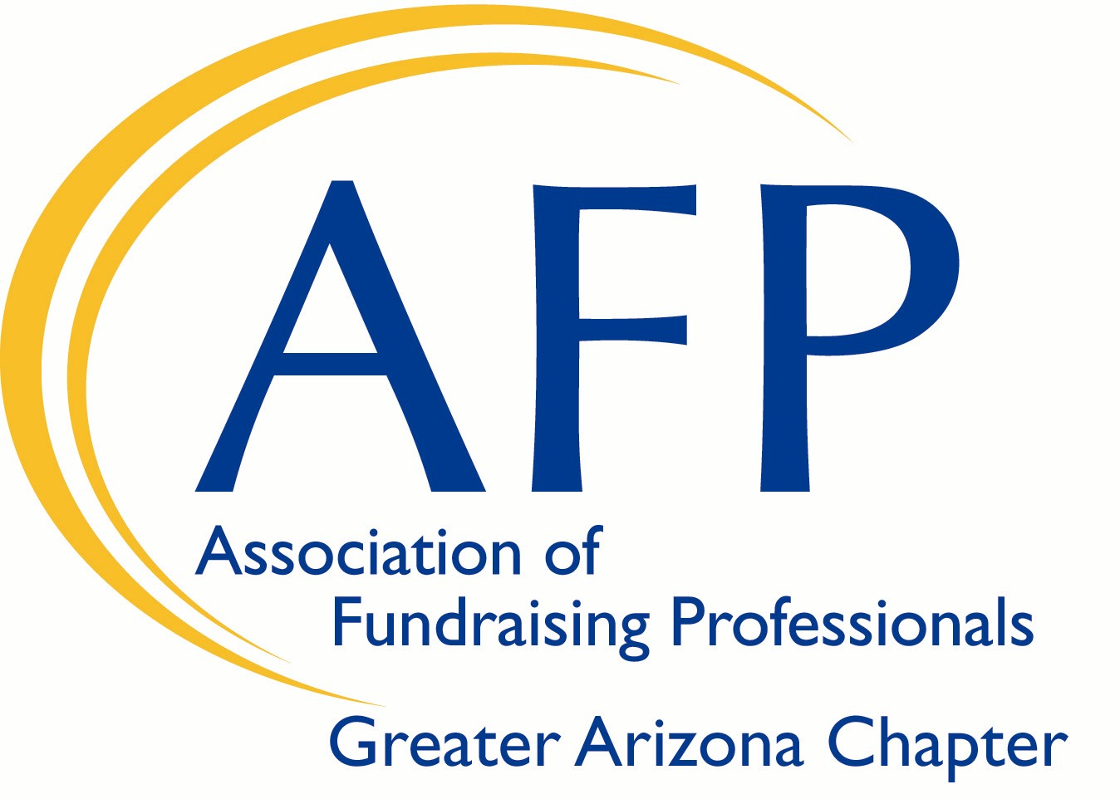

Greater Arizona Chapter of
Association of Fundraising Professionals (AFP)

IDEA Scholarship Program

AFP is committed to the principles of inclusion, diversity, equity and access (IDEA) in the fundraising profession, the philanthropic sector and throughout all of society. AFP is involved in numerous projects and partnerships related to IDEA.

The Greater Arizona Chapter of Association of Fundraising Professionals seeks to engage and involve members of diverse groups regardless of age, color, disability, ethnicity, family or marital status, gender identity or expression, language, national origin, physical and mental ability, race, religion, sexual orientation, veteran status, and other characteristics that make them unique; with a focus on fundraising issues and to promote fundraising as a career.

The Chapter’s goal is to promote diversity among our members in order to attract and recruit from these diverse communities. Additionally, the Greater Arizona Chapter seeks to advance philanthropy by promoting a better appreciation of how culture, religion and different lifestyles may impact the way people view philanthropy.

In alignment with the Chapter’s IDEA Standards, two (2) scholarships will be offered for one (1) full year of membership dues (throughout 2021). These scholarships are reserved for new members only and for applicants who identify themselves as members of a diverse community of fundraising professionals or those who are employed by a nonprofit organization that serves a diverse community.

ELIGIBILITY CRITERIA: To be awarded the Greater Arizona Chapter of Association of Fundraising Professionals IDEA Membership Scholarship, the recipient must:
- Be a fundraising professional who self identifies as coming from an eligible diverse community as defined by the Greater Arizona Chapter of AFP or be a fundraising professional employed by an organization serving an eligible AFP diverse community/communities.
- Consider participation as a member of the IDEA Committee of the Greater Arizona Chapter Association of Fundraising Professionals (AFP) for 2021.
- Fully complete the scholarship application and submit by November 30th, 2020.

Greater Arizona Chapter of
Association of Fundraising Professionals (AFP)
IDEA Scholarship Program
Scholarship Application
- Personal Data

Applicant’s Name:
Job Title:
Empoyer:
Business Address:
City: State: Zip:
Business Phone Number: Mobile Phone Number:
Email Address: Website URL:

- Background Information

Year in the Profession:
Previous Training in Fundraising:

- In 300 words or less, please answer the following question:

If you receive the membership scholarship, how do you believe you can help AFP Greater Arizona Chapter accomplish its IDEA goals to “work continuously to enable people of all races, genders, cultures and perspectives to practice effective and ethical fundraising for their organizations and community”?

Applications will be reviewed by the IDEA Committee. Scholarships will be awarded to two individuals. The cost of the annual AFP membership will need to be covered first by the individual/their organization. The expense will then be submitted and reimbursed by AFP International.

Application deadline: November 30th by 5PM

Applications should be returned to:
Jessica Whitney, IDEA Chair, AFP Greater Arizona Chapter
jwhitney@bbbsaz.org Questions: 480-236-6476

