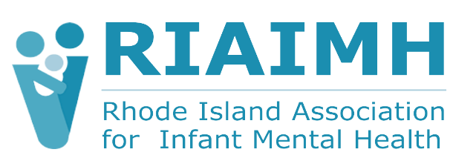

Position Profile: Executive Director RI Association for Infant Mental Health
The Rhode Island Association for Infant Mental Health (RIAIMH) is currently seeking an Executive Director (ED) to lead the strategic direction for RIAIMH’s future, working in partnership with Board, staff, members, and community partners to nurture strong relationships among infants, young children, and the adults who care for them. With a passion for RIAIMH’s critically important work to provide services to people who work with young children and their families, the ED will build upon the legacy of RIAIMH, a well-respected, trusted provider and champion of infants, young children, and families. They will manage a budget close to $1 million, a staff of 3 employees and 15 consultants, serving almost 300 members. The ED reports to the Board of Directors, a dynamic group of strategic, highly engaged community, private, and public sector leaders.

Established in 2002, RIAIMH is a community-based, non-profit 501(c)(3) organization that supports reflective, relationship-based, equitable, and evidence-based practices rooted in theoretical knowledge and scientific inquiry that help professionals promote infant and early childhood mental health. For information and to view the full profile visit https://riaimh.org

The ED is responsible for advancing the organization’s mission by building strategic partnerships, overseeing administration of equity-driven workforce development and professional educational programs, and developing the strategic plan. They ensure financial sustainability through grants acquisition, direct fundraising, marketing, and community outreach and manage the organization’s resources. The ED will guide the growth of the organization and further the mission by building relationships throughout the community, members, and partners. This is a full-time hybrid position, minimum 4-day work week, on-site in Providence at least 50% of the time.

The ideal candidate has a bachelor’s degree, related coursework or advanced studies, eligible and willing to receive relevant certifications and has experience working with or on behalf of infants, children, and families. With a minimum of 3 years of leadership experience they will be proficient in grant writing, financial management, and building and leveraging relationships within and among a diverse group of stakeholders. With superior communication skills and commitment to building a team-based work environment, the ED will be a compassionate leader and a collaborator who can lead efforts in equity and cultural responsiveness through reflective practices, dedicated to anti-racism. Bilingual /multilingual candidates are preferred.

The target salary range is $95,000-$120,000 annually. Compensation is commensurate with experience and qualifications. RIAIMH is fully committed to a culturally diverse staff to better serve our community. People of color, women, LGBTQ+ candidates, and people of diverse backgrounds are encouraged to apply. All applications received by January 9, 2026 will be given full consideration by the search committee. Candidates should submit a resume and cover letter describing their interest in this position, references, and salary requirements to: Cynthia Butler, SPHR, SHRM-SCP, Butler & Associates Human Resources Consulting at cjbutlerhr@gmail.com

