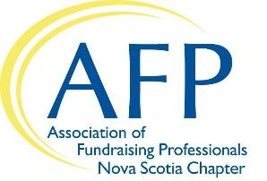


AFP Nova Scotia & CAGP Nova Scotia
Mentor Application

The AFP Nova Scotia & CAGP Nova Scotia Chapters are delighted that you are interested in being a mentor. This program will provide new fundraisers with a supportive environment that facilitates learning and knowledge exchange. Mentoring is a one-year commitment with a six-month review with the Mentorship Coordinator to ensure the match is suitable for both you and your apprentice.

Thank you for doing your part to grow the capacity of our sector in Nova Scotia.

Contact Info
Title
Name
Organization
Position
Address
City |  | Prov |  | Postal
Phone
Email

Are you willing to meet with your mentee once a month?
Yes No

How many years have you been in fundraising?

Briefly describe your educational and employment history.

Sector of Fundraising

Your apprentice might be interested in learning more about a certain area of fundraising and/or specific skill from their mentor. Please check the fundraising sectors and skills you are interested in mentoring:
Annual Giving
Planned Giving
Direct Mail
Other:
Events
Donor Stewardship
Major Gifts

Fundraising Skills

Multitasking
Public speaking/presentations
Problem solving
Other Skills:
Leadership
Teamwork
Communication skills

What do you hope to get out of participating in this program?

What are your preferences regarding a match?

References
Please provide us with one reference (professional or personal) that we can contact:

Name
Relationship
Phone
Email

By submitting this application, you agree to following terms:

I am aware that the time commitment is for one year. I understand that some information that will be shared by my mentee about his/her organization can be confidential in nature and I will respect this fact. I understand that the Mentorship Committee has the authority to make the decision as to whether or not I will be accepted into the Mentorship Program.

Check here to agree

Next steps
After completing this application form, email it to the Mentorship Chairs, and they will contact you with a match. Please contact us at any time if you have any questions. Thank you for your willingness to offer your time and expertise to other fundraisers!

Mentorship Committee:
AFP Mentorship Chairs: mentorshipwithafp@gmail.com
CAGP Mentorship Chair: terri.mann@dal.ca

