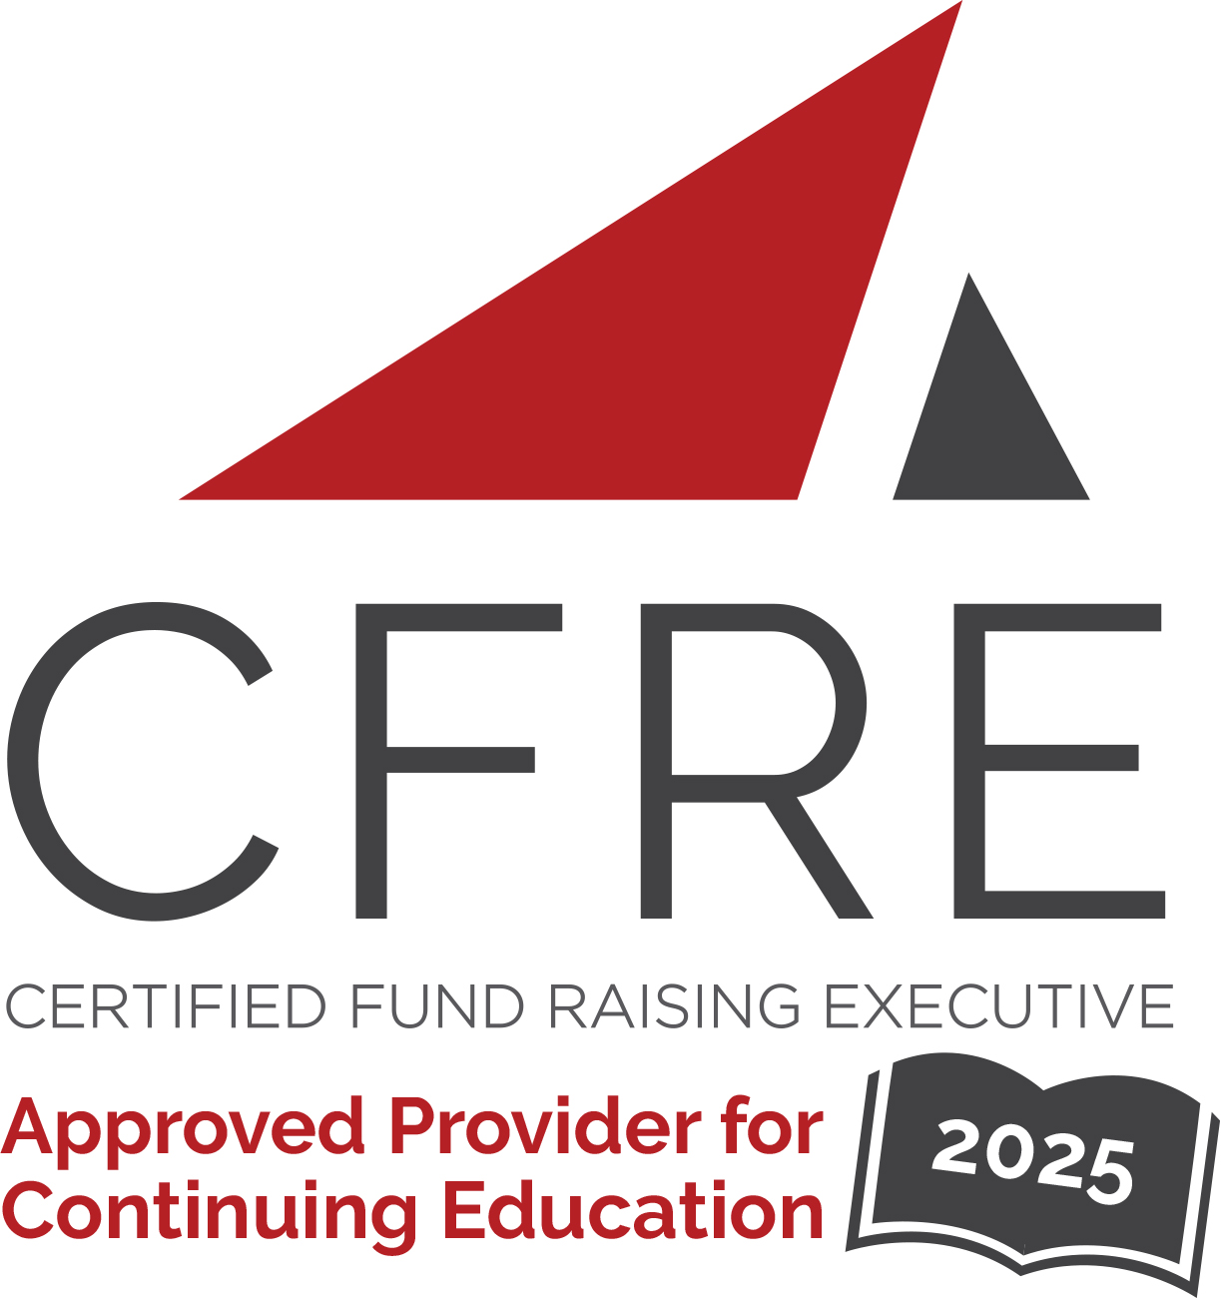  CFRE International has developed this form as a way for you to quickly track (and keep in your files!) the continuing education sessions you have attended. Simply check the boxes next to the sessions you attended. At the end of the conference, add up the total number of hours. Keep this sheet and you will be ready to complete your application form. All of the session slots listed are eligible for continuing education points on your CFRE application for initial certification and/or recertification. Sessions not listed here are not eligible for points. |  | CONTINUING EDUCATION POINTS TRACKER

Activity Organizer: - AFP Nova Scotia Chapter
Title of Activity: - Maritime Fundraising Conference 2025
Names of Presenter(s): - Various
Dates and Location: - 16 September, 2025 – Halifax, Nova Scotia

Date: 16 September, 2025
Session 1: 9:50am – 10:50am (1 pt)
- 1A: Mission, Message, Money: Storytelling That Inspires Donor Engagement
- 1B: From Donations to Collaborations: Unlocking the Full Potential of Stakeholders

Date: 16 September, 2025
Session 2: 11:00am – 12:00pm (1 pt)
- 2A: We Come In Peace! From Eye Rolls to High Fives: Building Buy-In Across Your Team
- 2B: Biscuits With the Boss: Believe in the Power of Moments and the Impact of Great Stewardship

Date: 16 September, 2025
Keynote: 12:27pm – 1:40pm (1.25 pts)
- Keynote: The Fragile Commodity of Trust and the Achor of Kinship

Date: 16 September, 2025
Session 3: 1:50pm – 2:50pm (1 pt)
- 3A: Assessing What Your Organization Needs to Advance
- 3B: Staying Strong When the Mission Feels Heavy: Mental Fitness in a Changing World

Date: 16 September, 2025
Session 4: 3:10pm – 4:10pm (1 pt)
- 4A: Navigating AI in Fundraising: From Fear to Function
- 4B: From Burnout to Boundaries: Creating a Sustainable Grant Strategy

Total number of points attained: __________

