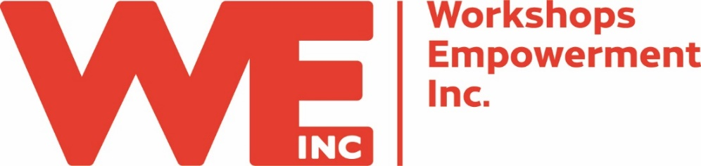
Job Description: Director of Development & Marketing

Reports to: Executive Director
Classification: Full time, Exempt
Date Reviewed: January 2022

Position Summary:
Responsible for effectively managing Workshops Empowerment Inc.’s fund development program and developing and implementing a consistent marketing message. This senior-level staff person will serve as a member of the organization’s management team, and as such is also responsible for helping to shape and lead the organization’s future.

To apply, send resume and cover letter to jobs@weincal.org

Responsibilities & Essential Functions:
- Provide a vision and written annual plan for the fund development efforts and goals of WE Inc. The fund development program includes major gifts from individuals, foundations and corporations; annual giving; research, data entry, gift processing and acknowledgments; stewardship of donors and donations; and management of special events. Oversee and monitor progress against goals
- Communicate the Workshops Empowerment Inc. mission, vision, and values to our many constituents
- Manage up to the Executive Director, ensuring she is focused on high-level development priorities and manage out to the board, ensuring they can do the same. This includes identifying key community relationships and developing strategies for cultivation.
- Identify, qualify, cultivate, solicit and steward prospective donors. Set and meet agreed upon dollar and non-dollar goals for all aspects of fund development
- Work with management team to translate critical needs into specific giving opportunities for donors and develop plans to secure these gifts.
- In cooperation with and support of volunteer leadership, direct all aspects of the WE Inc. Junior Board including recruitment, maintaining list of prospective members, orientation, communications and the coordination of activities.
- Plan and implement annual fundraising events, including planning for soliciting sponsorships. Annual events for 2022 include the inaugural Great Birmingham Bake Off and likely one additional web-based event.
- Implement guidelines for donor stewardship and recognition, with the intent of making the giving experience satisfying and rewarding. Ensure that stewardship activities include maintaining donor records, thanking donors in a timely manner and often, and ensuring that gifts are used according to each donor’s designation
- Provide administrative support to the Development and Marketing Committees of the Board of Directors.
- Lead the organization’s external messaging strategic priority of creating a marketing program with focused messaging that bolsters the immediate recognition of Workshops as the premiere provider of employment services for people with disabilities and other barriers to employment AND as the go-to source for outsourcing solutions. This includes determining the most cost-efficient and effective means of communicating to constituents.
- Seek opportunities to be an active and visible member of the community, build and maintain appropriate external relationships and coalitions with the support of the Executive Director, senior staff and Board of Directors.
- Inform, involve, and bond the constituency to the organization. Remain fully accountable to the constituency through annual and stewardship reports and other communications.
- Manage all aspects of development records management/software system including: accurate tracking, updates, data accuracy, clean-up, acknowledgment process for gifts, recording of actions and communications.
- Manage the Executive Assistant with regard to her development and/or marketing responsibilities.
- Serve as a member of the management team by staying abreast of organization-wide issues, and contributing to the overall management of the organization.
- And of course, additional duties as assigned or as they arise.

Job Requirements:
- Bachelor’s degree from an accredited 4-year institution required
- An articulated belief in the mission of Workshops Empowerment Inc.
- A proven track record as a fund development professional with experience in the field of 5+ years
- Experience with donor database software (we use eTapestry)
- Excellent communications skills, both oral and written
- Integrity
- A sense of humor
- Ability to lead and manage people, self-directed with ability to communicate high priority issues to senior management
- Excellent planning and organizational skills, including the ability to manage multiple projects at once, meet deadlines and produce excellent results
- Attention to detail
- Excellent judgment and discretion with confidential information
- Self-motivated and committed professional
- Computer proficiency (Microsoft office suite, donor database, social media)

Job Conditions:
This position requires the individual to work alone and/or with others, and to work on numerous concurrent tasks, occasionally working evening and/or weekends. Other work conditions may include working with office equipment, and extended work on computers.
Workshops Empowerment Inc. provides equal employment opportunities to all employees and applicants for employment and prohibits discrimination and harassment of any type without regard to race, color, religion, age, sex, national origin, disability status, genetics, protected veteran status, sexual orientation, gender identity or expression, or any other characteristic protected by federal, state or local laws.

