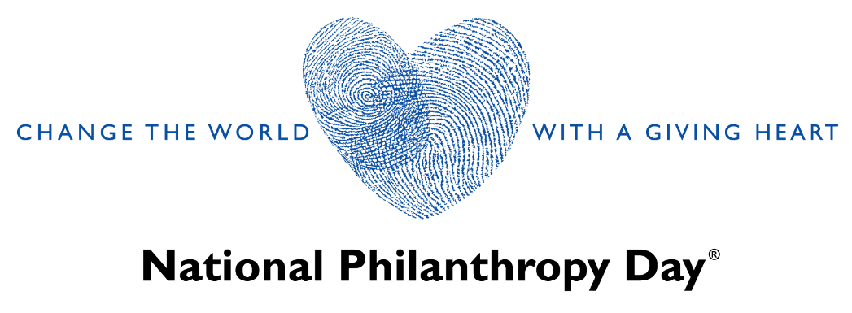

2022 NATIONAL PHILANTHROPY DAY SPONSORSHIP LEVELS & BENEFITS

Presenting Sponsor - $7,500 (1 Available)
- Prominent name and logo recognition as the Presenting Sponsor in event and publicity materials including:
  - AFP First Coast Chapter National Philanthropy Day webpage
  - National Philanthropy Day invitation, program, and video
  - Any AFP First Coast Chapter e-newsletter articles about National Philanthropy Day
- Full-page advertisement in National Philanthropy Day printed program
- Spotlight in social media before and after the event, including a paragraph and link to Presenting Sponsor’s website.
- Boosting of Facebook social media post.
- Brief speaking opportunity at the National Philanthropy Day Luncheon.
- Opportunity to have a promotional item included in the reception arrangements.
- Two tables in premier seating at Luncheon.
- Visibility with an audience of community leaders, professionals, and major philanthropists

Community Partner - $5,000 (Unlimited)
- Name and logo recognition as a Community Partner sponsor in event and publicity materials including:
  - AFP First Coast Chapter National Philanthropy Day webpage
  - National Philanthropy Day invitation, program, and video
  - Any AFP First Coast Chapter e-newsletter articles about National Philanthropy Day
- Half-page advertisement in National Philanthropy Day printed program (Qty: 650)
- Spotlight in social media before event, including a paragraph and link to sponsor’s website.
- One table in premier seating at Luncheon.
- Visibility with an audience of community leaders, professionals, and major philanthropists.

Community Supporter - $2,500 (Unlimited)
- Name and logo recognition as a Community Partner sponsor in event and publicity materials including:
  - AFP First Coast Chapter National Philanthropy Day webpage
  - National Philanthropy Day invitation, program, and video
  - Any AFP First Coast Chapter e-newsletter articles about National Philanthropy Day
- Quarter-page advertisement in National Philanthropy Day printed program (Qty: 650)
- Name recognition in social media posts
- Four (4) Luncheon tickets in premier seating
- Visibility with an audience of community leaders, professionals, and major philanthropists.

2022 NATIONAL PHILANTHROPY DAY SPONSORSHIP AGREEMENT
Monday, November 14, 2022 | Hyatt Regency Jacksonville Riverfront

Important: To ensure your company/organization receives coverage in all AFP event and publicity mediums as outlined in the Sponsorship Levels & Benefits, please submit completed Sponsorship Agreement and payment by August 1, 2022.

Contact Name:
Company/Organization:
Address:
City/State/Zip:
Phone:
Email:

Sponsorship Level: $7,500 Presenting
$5,000 Community Partner
$2,500 Community Supporter

For recognition purposes, please list company name as:
*Please send your logo in .eps or .gif to Lacey Rumberger at lrumberger@arcjacksonville.org

Sorry, a full sponsorship is not an option this year, however, I would like to help support advancing philanthropy in our community with a gift in the amount of $ .

Signature: Date:

Method of Payment:

Credit Card: Please complete this agreement and make your payment through the AFP First Coast Chapter Website at afpflfirstcoast.afpnet.org

Check: Please make your check payable to the Association of Fundraising Professionals and return it with this completed form to: AFP First Coast Chapter, PO Box 43024, Jacksonville, FL 32202-3024

Thank you for supporting the advancement of philanthropy in our community!

