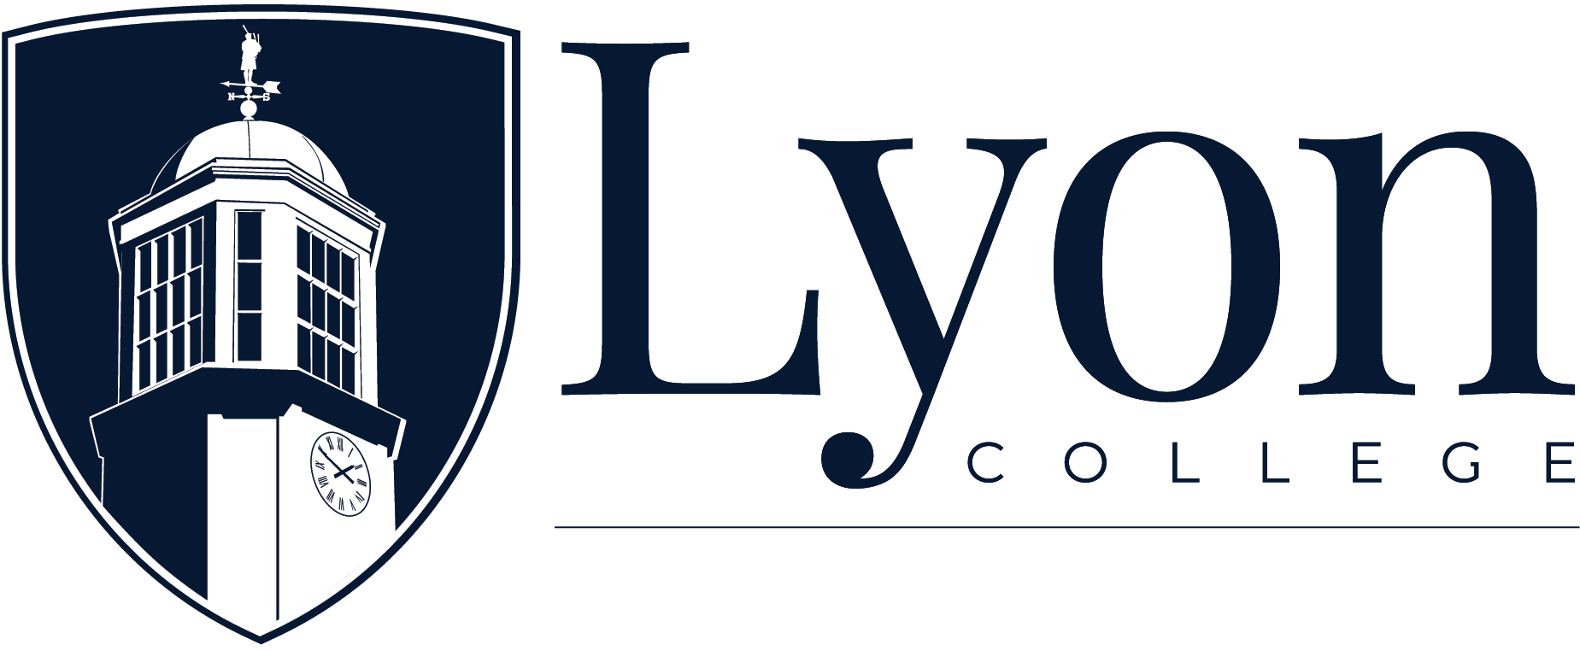
OFFICE OF HUMAN RESOURCES

Position Description

Title: Vice President of Institutional Advancement
Classiﬁcation: Exempt, Full-time
Component: Advancement
Reports to: President
Date: May, 2026
Scope of Position: Lyon College, a growing and dynamic institution of higher education in Arkansas, associated with the Presbyterian Church U.S.A., with rigorous undergraduate and graduate programs, seeks an experienced and accomplished Vice President of Institutional Advancement. The VPIA serves as the chief fundraising and external relations officer, responsible for developing and executing comprehensive strategies to enhance philanthropic support, alumni engagement, and institutional visibility for the three campuses of the Lyon College System: the School of Liberal Arts in Batesville, the School of Dental Medicine in Little Rock, and the School of Veterinary Medicine in Cabot. Reporting directly to the President, the VPIA provides strategic leadership to advance the college’s mission, goals, and priorities through effective fundraising and constituent relations efforts.

ESSENTIAL JOB FUNCTIONS:

- Develop and implement strategic fundraising plans that align with the college’s strategic priorities and fundraising goals.
- Implement proven, industry-referenced best practices (e.g., CASE standards) and data-driven methodologies to optimize campaigns, enhance constituent engagement, and ensure measurable fundraising growth.
- Provide visionary leadership and direction to the Office of Institutional Advancement, fostering a culture of philanthropy and engagement among staff, volunteers, and stakeholders.
- Cultivate and steward relationships with major donors, alumni, foundations, corporations, and other prospective supporters to secure philanthropic gifts and grants in support of institutional priorities.
- Oversee major gift fundraising, planned giving programs, annual giving campaigns, and special fundraising initiatives, ensuring effective donor cultivation and solicitation strategies.
- Develop and implement strategies to enhance alumni engagement, involvement, and support through alumni events, programs, communications, and volunteer opportunities.
- Collaborate with the Alumni Relations Office to strengthen alumni networks, promote alumni participation, and leverage alumni support for institutional advancement efforts.
- Enhance the college’s visibility and reputation through strategic communications, media relations, and public relations campaigns.
- Serve as a spokesperson for the college and cultivate positive relationships with the media, community leaders, and stakeholders to promote the college’s mission and accomplishments.
- Support the Board of Trustees and other volunteer leadership in their fundraising and advocacy roles, providing staff support, strategic guidance, and facilitating effective board engagement.
- Serve as a key liaison between the college administration, faculty, staff, and external stakeholders to advance institutional priorities and fundraising initiatives.
- Develop and manage the Institutional Advancement budget, ensuring responsible stewardship of financial resources and alignment with fundraising goals and outcomes.
- Monitor fundraising performance, analyze data, and prepare reports for senior leadership and the Board of Trustees on fundraising progress, trends, and opportunities.
- Cultivate and maintain strategic partnerships with community organizations, businesses, and other institutions to enhance fundraising opportunities, collaborative initiatives, and resource development.
- Collaborate with academic and administrative leaders to integrate institutional advancement efforts into broader institutional planning and initiatives.
- Support the development of the Advancement team members
- Other duties as assigned.

MINIMUM QUALIFICATIONS/REQUIRED SKILLS:

- Master’s degree in business administration, Nonprofit Management, Public Administration, or a related field; a Ph.D. or equivalent experience is preferred.
- Minimum of 3 years of senior leadership experience in institutional advancement, fundraising, or related fields, preferably within higher education or a nonprofit organization.
- Demonstrated success in major gift fundraising, donor relations, and campaign management, with a track record of securing significant philanthropic support.
- Strong interpersonal, communication, and negotiation skills, with the ability to build and maintain effective relationships with diverse constituencies.
- Physical ability to recognize data in the written form (i.e. checks, reports, etc.) so as to enter data in a computer system.
- Physical ability to sit for extended periods of time (i.e. computer).
- Physical ability to use the telephone to conduct business.
- Physical ability to stand and to lift moderate weight.

The employee of this role is expected to adhere to all company policies while employed. Responsibilities and tasks outlined in this document are not exhaustive and may change

as determined by the needs of the company. I have read and understand the contents of this job description.

Signature: Date:

Lyon College
P. O. Box 2317
Batesville, AR 72503

