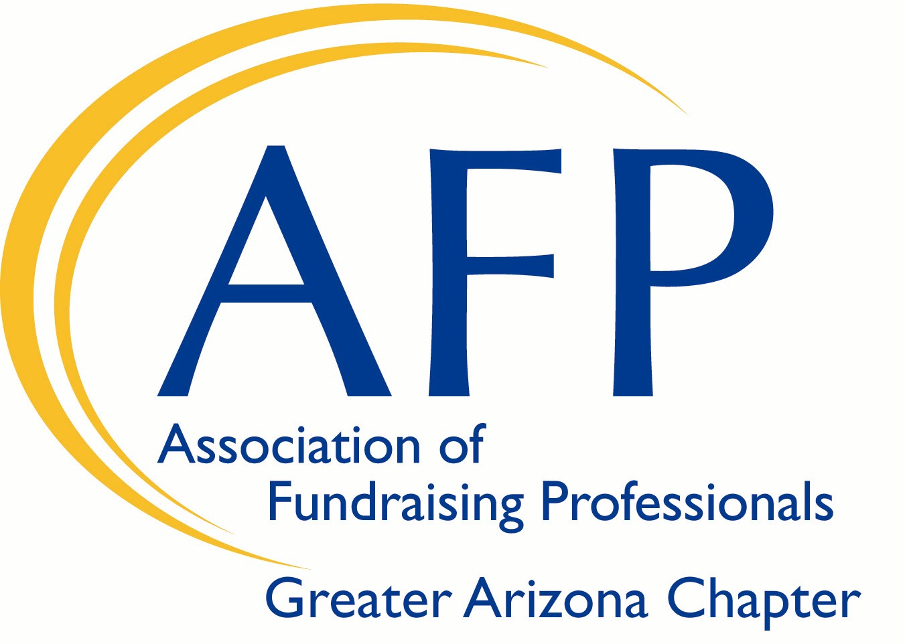

Greater Arizona Chapter of
Association of Fundraising Professionals (AFP)

October 3-5, 2019 AFP LEAD Conference
Scholarship Program

The Greater Arizona Chapter of Association of Fundraising Professionals seeks to engage and involve members of diverse groups regardless of age, color, disability, ethnicity, family or marital status, gender identity or expression, language, national origin, physical and mental ability, race, religion, sexual orientation, veteran status, and other characteristics that make them unique; with a focus on fundraising issues and to promote fundraising as a career.

The Chapter’s goal is to promote diversity among our members in order to attract and recruit from these diverse communities. Additionally, the Greater Arizona Chapter seeks to advance philanthropy by promoting a better appreciation of how culture, religion and different lifestyles may impact the way people view philanthropy.

In alignment with the Chapter’s Diversity Plan, two (2) $400 scholarships will be offered for the October 2019 AFP LEAD conference. These scholarships are reserved for applicants who identify themselves as members of the AFP diverse community of fundraising professionals or AFP members who are employees of a nonprofit organization that serves a diverse community.

ELIGIBILITY CRITERIA: To be awarded the Greater Arizona Chapter of Association of Fundraising Professionals Statewide Conference Scholarship, the recipient must:
- Be an AFP member in good standing.
- Be a fundraising professional who self identifies as coming from an eligible diverse community as defined by the Greater Arizona Chapter of AFP or be a fundraising professional or fundraising executive director employed by an eligible AFP diverse community where 50% or more staff members are from that or other diverse community.
- If selected, you must attend the conference and provide any additional funds to cover expenses beyond those covered by the scholarship.
- Submit a post-conference evaluation by November 5, 2019.
- Consider participation as a member of the Diversity Committee of the Greater Arizona Chapter Association of Fundraising Professionals (AFP) for 2019/2020
- Fully complete the scholarship application and submit by September 18th, 2019.

Greater Arizona Chapter of
Association of Fundraising Professionals (AFP)
October 3-5, 2019 AFP LEAD Conference
Scholarship Program
Scholarship Application
- Personal Data

Applicant’s Name:
Job Title:
Empoyer:
Business Address:
City: State: Zip:
Business Phone Number: Mobile Phone Number:
Email Address: Website URL:

- Background Information

Year in the Profession:
Previous Training in Fundraising:

- In 300 words or less, please answer the following question:

If you receive the scholarship, how do you believe you can help AFP Greater Arizona Chapter accomplish its diversity goal to “work continuously to enable people of all races, genders, cultures and perspectives to practice effective and ethical fundraising for their organizations and community”?

Scholarships will be awarded to two individuals at $400 each. The cost of the conference is $599 or $399 for young professionals. Recipients/recipients’ organizations will be required to cover the remainder of the registration fees if applicable.

Application deadline: September 18, 2019 by 5PM

Applications should be returned to:
Jessica Whitney, Diversity Chair, AFP Greater Arizona Chapter
jwhitney@bbbsaz.org Questions: 602.393.4115

