AFP Professional Mentoring Program

MENTEE
2023 Application

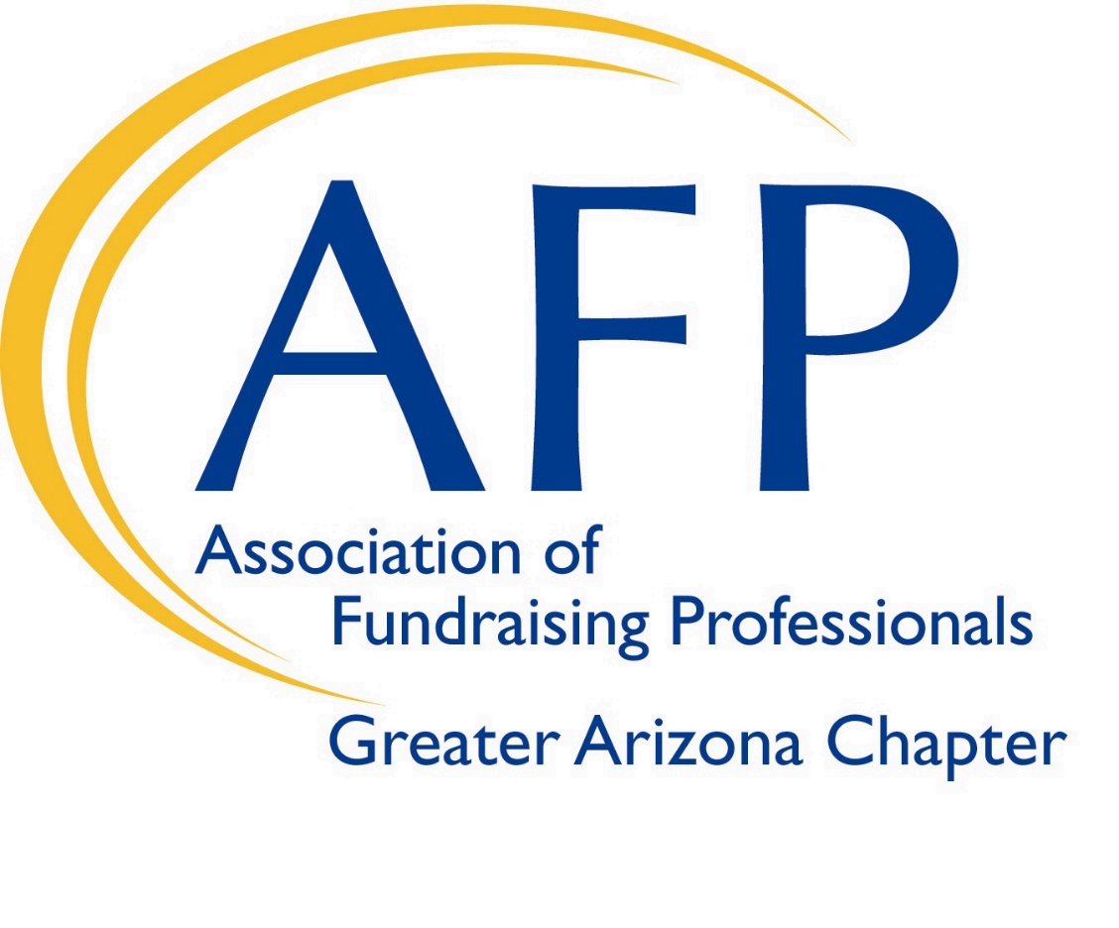

Association of Fundraising Professionals - Greater Arizona Chapter
7375 E. 6th Avenue, #9, Scottsdale, AZ 85251
admin@afpaz.org | Phone: (480) 947-3459 | Fax: (480) 990-1889

https://community.afpglobal.org/afpazgreaterarizonachapter/home

Dear Mentee Applicant,

Ask successful leaders and managers what the key to their own career success is and most of them will tell you they had great mentors and will attribute significance to those relationships in supporting their career trajectory.

Mentors tend to be unbiased. Sure, you can ask family and friends what to do about a certain work situation, but a person who's been in your shoes, aka your mentor, probably knows best. Even if they have not had your exact job before, chances are, they know the industry and can help you determine what your best choices are to address the issue. Their only agenda is to help you achieve your goals.

Most of us didn’t grow up dreaming of being fundraisers, or study fundraising in college. When you ask a fundraising professional how they got into the field, more often than not, you’ll hear some variation of, “Well…I just fell into it!”
So, it makes sense that most fundraising professionals learn on the job. With this in mind, 25 years ago, the Greater Arizona Chapter developed the Mentoring Program for professionals new to the field. Now adopted as a model by AFP International, this year-long program offers new fundraising professionals the foundation they need for a successful career.

This program is designed for professionals that are newer to the field (1-5 years) – whether a young professional or one making a mid-career change!
Over the course of a year, AFP Mentees will:
- Participate in educational workshops covering key fundraising topics and skills to expand their knowledge and experience
- Be matched with a veteran professional fundraising mentor
- Grow their network in the fundraising community
- Plan and execute a strategic fundraising-related project for their organization
- Present their final project to an audience of fundraising professionals
- Develop a solid foundation for a successful career in the fundraising field

Mentees have found many benefits, both personally and professionally by participating in the AFP Professional Mentor Program. These include, but are not limited to:
- Prestige of participating in the highly recognized AFP Greater AZ Chapter Professional Mentoring Program
- Pride of having an employer that is willing to invest in their future skills and career
- Being encouraged and empowered in professional development - preparation for the future and heightened career aspirations
- Opportunity for a hands-on professional development with proven, practiced, and structured curriculum at a low cost
- Opportunity to expand skills and knowledge of fundraising practices
- Personal and professional development, including increased job-related wellbeing, self-esteem and confidence, and better work-life balance
- Increased confidence in their ability to provide value and make an impact
  - Developing and maintaining a broader perspective on career options and opportunities
- Increased productivity, better time management and a higher rate of promotion
- Greater job satisfaction and minimizing need for “job jumping”
- Opportunities to establish a variety of professional relationships for long term association
- Build leadership, teamwork, and communication with peer professionals
- Earn CFRE credit to begin a path towards achieving credentials
- Public recognition for the mentee and their sponsoring employer (certificate, newsletter, monthly meetings)
- And more….

The Arizona nonprofit sector is a strong and vibrant community full of people willing to help each other out. We are fortunate to have a dynamic and successful pool of development professionals who chose to support the future of an industry they have committed their professional life to by mentoring our AFP mentees. As experienced leaders, they will play a significant role in encouraging your drive toward success.

Thank you for your interest in joining our 2023 Mentee Class. We look forward to another successful year of education, mentorship, inspiration, productivity, and camaraderie. If you have any questions or would like to discuss the opportunity with an AFP Program Committee member, please contact the AFP
Greater Arizona Chapter at admin@afpaz.org or (480) 947-3459.

Sincerely,

AFP 2023 Professional Mentoring Committee Members

Key dates for reference:
- AFP Mentor-Mentee commitments will begin in January 2023 and completed November 2023
- Mentee applications due no later than Friday October 28, 2022
- Mentee/Mentor assignments will be communicated no later than Friday, January 20, 2023
- Required Orientation for Mentor and Mentee is Wednesday, February 1, 2023, 1:30 – 2:30 p.m., First Workshop immediately to follow from 2:30-4:30 p.m.
- Mentee Final Presentation and Graduation, Mentor Recognition will be in November 2023

Criteria, Expectations and Requirements

Requirements: Supervisor Initials ___________________
- Mentees are required to be a current AFP member in good standing or an applicant for membership in the Greater Arizona Chapter
- Be employed in a full-time professional position where fundraising is a primary job responsibility. *
- Have less than five years’ experience in the fundraising profession.

*Carefully evaluated positions that are less than full-time or combine volunteer positions in fundraising may be considered for equivalency.

Time Commitment*: Supervisor Initials ___________________
*Estimated – will vary based on decisions by mentee/mentor

- Timeline: Program begins February 2023 and is completed in November 2023.

- Mark your Calendar NOW: The Orientation is a REQUIRED meeting for all 2023 Mentors and Mentees. It will be held on Wednesday, February 1, 2023, from 1:30 p.m.-2:30 p.m. The first workshop will immediately follow from 2:30-4:30 p.m. Failure to attend this orientation and workshop meeting by Mentees may result in the candidate being automatically dropped from the program.

Time Commitment: 3 hours

- Curriculum: The core curriculum will focus on critical elements of a comprehensive annual fundraising effort and will explore other aspects of a comprehensive development program. The Workshop schedule is established and communicated at orientation to facilitate attendance.
  - Volunteer presenters with high levels of experience and knowledge of the topic are recruited by the Mentor Program Committee
  - Each speaker structures their own presentation using an outline with information to be covered for that topic
  - Workshop locations may vary as an added benefit for mentees to learn about other nonprofit organizations in the Metro Phoenix region

Time Commitment: 42 hours cumulative estimated

- Fundraising Service Project: Mentees are required to complete a fundraising service project that is focused on a component of their organization’s annual fund effort. Projects will be proposed by the mentees, approved by their organizations, reviewed, and approved by the Professional Mentor Program committee.
  - Mentors will offer continued guidance on the direction and fulfilling the desired results of the project.
  - Mentees will present the project, learning objectives and outcomes at the end of year Graduation
  - Further information on the fundraising service project can be found in the program guidelines.

Time Commitment: 25-35 hours cumulative estimated

- Mentee/Mentor Match: Every effort will be made to match mentees with mentors based on the needs of the mentee, the mentors’ areas of expertise, and the type of organization for which they both work as well as other key partnership considerations. Mentors are preferred to hold any of the following credentials: CFRE, ACFRE, or FAHP designation, be a current AFP Member in good standing and have actively demonstrated service to the profession and community.

Time Commitment: 2- 3 hours per month estimated

NOTE: Mentors are NOT consultants to the organization or the mentee. They are NOT expected to volunteer their time or services toward the organization or the service project, but rather to provide advice and support to the INDIVIDUAL mentee as they prepare and execute the project.

Mentee Expectations: Supervisor Initials ___________________

- Mentees are expected to make workshops and program activities a priority in scheduling and make every reasonable effort to attend all curriculum workshops.
  - Missing More than 3 workshops (excused/unexcused) may result in mentee not receiving graduation certificate or possibly dismissal from program.
- Mentees are expected to conduct themselves in a professional manner including timeliness, communication, dress code, conduct, etc.
- Mentees are required to comply the AFP Code of Professional Conduct.
- Mentees are to respect the generosity of the Workshops speakers in volunteering their time, expertise and in preparing presentations. Any duplication or distribution of the presentation or handouts requires permission from the speaker/author.
- Report any changes in their job, employment status or other professional circumstances that relate to their position as a Mentee to their Mentor and the AFP Mentor Program Committee. The Committee will work with them to accommodate any reasonable changes.
- Provide current emails and phone numbers for everyday access.
- Failure to meet appropriate levels of professional expectations may result in the mentee being dismissed from the program.

Program Costs: Supervisor Initials ___________________
$ 595.00 Application fee due by November 30, 2022
$ AFP Membership Dues (See below for Membership Choices)
$ AFP Greater AZ Chapter Dues* (Based on Membership Choice)
$ Total Cost for Mentee/Organization

AFP Membership Options (Note: In some cases, a 2-year membership may provide a significant savings)

PROFESSIONAL MEMBER - $280.00 + $75.00 AFP Greater Arizona Chapter Dues
- Open to persons who hold some degree of responsibility directly for fundraising, work within the U.S. and Canada and are compensated for their services and its bylaws; subscribe to the AFP Code of Ethical Principles and Standards and its bylaws; promote the Donor Bill of Rights and, are employed or have been employed by an institution or organization that provides benefits to society.

ASSOCIATE - $280.00 + $75.00 AFP Greater Arizona Chapter Dues
- May be extended to persons who are engaged in fields related to fundraising, volunteers, or those who have mutual interests with fundraising professionals, and who subscribe to the AFP Code of Ethical Principles and Standards and its bylaws; and promote the Donor Bill of Rights.

YOUNG PROFESSIONAL - $95.00 (including chapter dues)
- Open to persons who hold some degree of responsibility directly for fundraising, work within the U.S. and Canada and are compensated for their services, and are 30 years old or younger, must subscribe to the AFP Code of Ethical Principles and Standards and its bylaws and promote the Donor Bill of Rights and be employed, or have been employed by an organization that provides benefits to society.

RETIRED - $75.00 + $75.00 AFP Greater Arizona Chapter Dues
- Retired membership in the Association shall be open to individuals who no longer practice as paid fundraising professionals but who, at the time they seek Retired Member status, have been Professional members of the Association for the immediate past five consecutive years and subscribe to the AFP Code of Ethical Principles and Standards and promote the Donor Bill of Rights.

Note: Scholarships for Professional Mentor Program tuition and/or AFP membership are available. Contact: scholarship@afpaz.org.

Application fees will not be refunded if the employee leaves the employment of the organization, is dismissed from the Program due to improper conduct, or voluntarily chooses to resign from the Program.

Professional Mentoring Program Application - 2023

Name:

Employer:

Primary Sector Focus:
□ Human Services □ Arts & Culture □ Healthcare □ Education □ Sports □ Faith Based
□ Other__________________

Work Address:
Telephone: E-mail:

Home Address:

Telephone: E-mail:

Employment Information

Position Title:

Current Supervisor’s Name:

Supervisor’s Title:

Supervisor’s Address:

Supervisor’s Telephone: _________________________________ Email: _______________________________

Your employing organization MUST be a 501(c)(3) non-profit.

- How many years has your organization been in existence? __________________________

- How many full-time staff does your organization employ? ___________________________

- What is the annual budget of your organization? __________________________________

- What is your organization’s current year fundraising goal? $_________________________

- What percentage of the annual budget is contributed income? ______________%

- Other primary sources of income include:

Professional Mentoring Program Application - 2023

Professional Information

1. Are you a member of AFP? [] Yes [] No

If yes, when did you become a member? ___________

If no and you are selected for the Mentoring Program, you must become a member by
January 31, 2023.

- Number of years of experience in fundraising: __________________________________

- Is your primary responsibility fundraising? [] Yes [] No

What percentage of your time do you spend on fundraising? ___________%

- Your response to this section will help the Mentoring Program Committee select a mentor and structure aspects of the curriculum that will meet your training and professional development needs. Indicate areas in which you want to develop skills:

Annual Giving Strategic Planning
Major Gifts Fundraising Stewardship
Corporate and Foundation Relations Prospect Research
Development Finance & Accounting Grant Writing
Capital Campaign Fundraising Special Events
Organizational Development Development Ethics
Board Development & Training Volunteer Training
Planned Giving/Endowment Building

- From the list above, select your top three priorities:

- ___________________________________

- ___________________________________

- ___________________________________

- You will be paired with a mentor for the entire program. What would you look for in an ideal mentor personally and professionally? What particular fundraising expertise would you find most helpful?

Professional Mentoring Program Application - 2023

- As a Mentee, you will be expected to assess the annual fundraising needs of your employer’s organization and complete a fundraising service project that addresses these needs. With the assistance of your mentor you will identify, plan, and implement this project, and will be evaluated on the project’s success.

Please list any ideas you may have regarding possible projects for this purpose.

_______________________________________________________________________________

_______________________________________________________________________________

_______________________________________________________________________________

_______________________________________________________________________________

Applicant’s Agreement

I have read the fact sheet regarding the program, and I understand and agree to the commitments and expectations of the AFP Professional Mentoring Program. I further understand that more than three absences may result in my not being considered an official graduate and/or being dropped from the program and that missing more than 30 minutes of a required session or workshop constitutes an absence.

I understand that decisions on acceptance to the program are made by the AFP Professional Mentoring Program Committee and are final.

Applicant’s Signature: ____________________________________________Date_________________

Supervisor’s Signature

I have read and initialed the fact sheet regarding the program, and I am aware of the commitments and expectation required of the above-named applicant who is employed by me. Should the applicant be chosen for the program, I agree to support him/her in fulfilling all the requirements of this year-long program.

Supervisor Signature _____________________________________________Date__________________

Supervisors Title: _____________________________________________________________________

Professional Mentoring Program Application – 2023

Applications are due by Friday October 28, 2022
- The application may be downloaded from the AFP Greater Phoenix Chapter website https://community.afpglobal.org/afpazgreaterarizonachapter/education/new-item3

- Required Attachments:
- Personal Statement of why you want to be considered for the AFP Professional Mentoring Program and what you hope to learn. (No more than one page).
- Supervisor’s Letter endorsing applicant (No more than one page).
- Your resume
- Your organization’s mission statement
- Your organization’s current fiscal year budget
- Check - $595 payable to Greater AZ Chapter AFP

- Return completed and signed application with attachments to:
AFP - Greater Arizona Chapter
c/o Mentoring Program Committee
7375 E. 6th Avenue, #9
Scottsdale, AZ 85251

Questions? Please contact the AFP Greater Arizona Chapter at admin@afpaz.org or (480) 947-3459.

For AFP Use only:

Date Application Received: _____________________________________________________________________

Name of AFP representative who received application: _______________________________________________

Approved by AFP Mentor Program Committee: YES NO

Date Communicated Application Results to Mentee: ________________________________________________

Name of AFP representative who communicated results: _____________________________________________

Notes: _____________________________________________________________________________________

