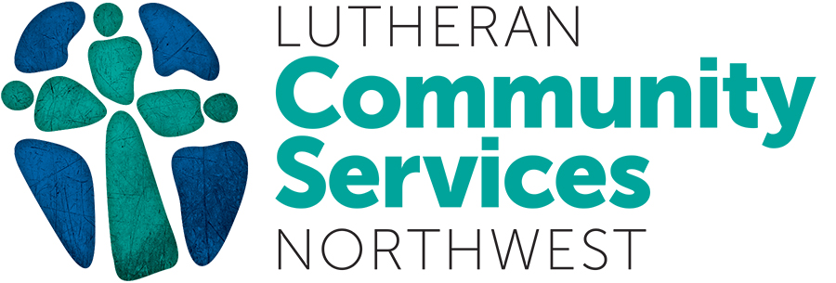

Title: Regional Advancement Manager
District Office: Shared Services Location: Seattle, Tacoma, Olympia, WA
Reports to: Director of Donor Relations Program: Advancement
FTE: 1.0 Salary Range: $71,000-$95,000
Status: Exempt

The Regional Advancement Manager is responsible for implementing the strategic fund-development plan that will provide for the on-going viability of the Lutheran Community Services NW (LCSNW) in the Puget Sound region. LCSNW partners with individuals, families and communities for health, justice and hope. We are proud to work with and serve people from different faiths, backgrounds, nationalities, cultures and sexualities.

The Regional Advancement Manager reports to the Director of Donor Relations (DDR), and works collaboratively with the Sr. District Directors. The ideal candidate has an entrepreneurial mind-set, is motivated to create highly-successful fundraising campaigns, and is driven to build new and sustainable donor populations and funding sources. This role requires enthusiasm for working with a mission-driven team to make a real and lasting difference for the future of the clients we serve, and of this dynamic nonprofit.

ESSENTIAL JOB FUNCTIONS/MAJOR JOB RESPONSIBILITIES:
In collaboration with the DDR and Regional leadership, develop and implement a comprehensive 3-year strategic fund-development plan that leads to meeting required operational funding goals to support the programs in the region (Everett, Seattle, SeaTac, Tacoma, Olympia).

• Tactical implementation of the comprehensive 3-year strategic fund-development plan will include:
1. A case statement that communicates funding needs and return-on-investment for potential partners.
2. Defining, updating, and maintaining a segmented donor list within the donor database.
3. Collaborating with leadership and the agency’s development team on major donor caseloads and corporate giving relationships.
• Strengthen commitment of established partners/donors to optimize their giving capacity.
• Conduct partner/donor solicitations to cultivate new donors.
• Identify and develop new sources of funding including: public, private, corporate, and foundation sources.
• Steward, cultivate and increase giving for current sources of funding including: public, private, corporate, and foundation sources.
• Promote and advocate for regional programs/services through presentations to community, corporate, government, congregational, and civic groups.
• Partner with communications team members to develop creative briefs to develop marketing communications materials that support fundraising efforts.
• Create, plan and execute special fundraising campaigns based on the needs of the organization.
• Coordinate partner and donor-focused events and campaigns, both in-person and virtual.
• Use social media effectively in fundraising efforts.
• Facilitate timely donor recognition for the region.
• Manage all donor/data tracking through CRM: includes data entry, activity tracking, etc.
• Manage team members as the advancement team grows in this region.
• Generate monthly reporting of progress toward established goals.
EDUCATION and/or EXPERIENCE: Bachelor’s or equivalent degree required. At least three years of fund-development experience within a nonprofit or government relations setting with a proven track record of success. Experience managing fundraising teams/personnel preferred. Experience in working in a multicultural setting, or with a multicultural client base is preferred. Candidates from diverse backgrounds are encouraged to apply. LCSNW is an equal opportunity employer, does not discriminate based on race, color, national origin, ethnicity, veteran, gender, sexual orientation, religion, age or disability, and is committed to workplace diversity. We encourage those who meet the basic requirements of the position to apply.

LANGUAGE SKILLS: Must have excellent communication skills with the ability to read, write, and speak English. Must have the ability to write effective memos, emails, donor acknowledgements, and other basic correspondence. Ability to effectively present information and respond to funders, government officials, clients, colleagues, and the general public.

MATHEMATICAL SKILLS: Ability to add, subtract, multiply, and divide in all units of measure, using whole numbers, common fractions, and decimals. Ability to compute rate, ratio, and percent and to draw and interpret graphs.

REASONING ABILITY: Ability to solve practical problems and deal with a variety of concrete variables in situations where only limited standardization exists. Ability to interpret a variety of instructions furnished in written, oral, diagram, or schedule form.

CERTIFICATES, LICENSES, REGISTRATIONS: OR State Driver’s License and auto insurance are required.

PHYSICAL DEMANDS/WORK ENVIRONMENT: The physical demands and work environment described here are representative of those that must be met/may be encountered by an employee to successfully perform the essential functions of this job. Reasonable accommodations may be made to enable individuals with disabilities to perform the essential functions. While performing the duties of this job, the employee is regularly required to sit and talk or hear. The employee is normally engaged in low-activity tasks such as sitting, standing, and walking. The work environment is typical of a professional office; the noise level is usually moderate. The employee must frequently lift and/or move up to 10 pounds and occasionally lift and/or move up to 25 pounds. Specific vision abilities required by this job include close vision, peripheral vision, and the ability to adjust focus.

Coordination tasks are generally performed in a normal office environment. However, some work is performed in a community-based site so travel to and from determined locations will be required.

