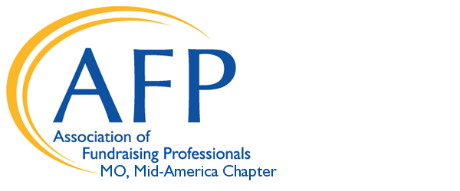
2019 AFP Chamberlain Scholarship Program- Mid-America Chapter
Deadline for applications: 5:00p.m. on Monday, October 1, 2018

Announcing an excellent opportunity for AFP members

The 56th Annual International Conference on Fundraising will take place March 31 – April 2, 2019, in San Antonio, TX. This is a wonderful opportunity for all members of the fundraising profession to sharpen their abilities and learn from their peers. This conference offers the broad spectrum, inspirational experience and the nuts-and-bolts, hands-on tactics to successfully achieve your vision for your organization. A conference of this caliber can be a truly transformative experience for any fundraising professional.

The Association of Fundraising Professionals (AFP) Mid-America Chapter offers one Chamberlain Scholarship covering the cost of conference registration (approximately a $799 value) PLUS another $500 to help cover travel and lodging costs as a one-time award to a deserving individual who has not attended a previous AFP International Conference. Note that Chamberlain Scholars are responsible for a $10 payment to secure the registration. To apply for this terrific opportunity, please fill out and return the scholarship application below on or before the October 1st deadline.

Chamberlain Scholar Responsibilities

Recipients of the Chamberlain Scholarship must
- Be a current member of AFP Mid-America Chapter
- Use scholarship funds only for attending the AFP International Conference
- Notify the Chapter President immediately if unable to attend the Conference
- Be available for a Chamberlain Scholar photo at the AFP International Conference
- Complete the required AFP International Conference scholarship evaluation form
- Serve on at least one AFP Mid-America Chapter committee in 2019
- Share knowledge gained at the Conference with AFP Mid-America Chapter

To apply for the Chamberlain Scholarship, complete the attached application with cover letter and return it via mail or email to:

AFP Mid-America Chapter
PO Box 32101
Kansas City, MO 64171
Phone: (816) 226-6383
afpmidamerica@gmail.com

ALL COMPLETED APPLICATIONS MUST BE RECEIVED BY Monday, OCTOBER 1, 2018

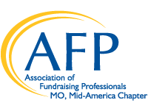 2019 Chamberlain Memorial Scholarship Application

I am applying for a scholarship to the 2019 International Conference March 31 – April 2 in San Antonio.
Applications must be received by 5:00 pm, October 1, 2018.

Eligibility
Recipients must:
- Have never attended an AFP or NSFRE International Conference
- Be a member of AFP Mid-America
- Be willing to serve on a chapter committee as a condition of receiving the scholarship
- Be responsible for fundraising for a 501 (c)(3) organization (at least 50% time)
- Complete the required AFP International Conference scholarship evaluation form
Application process:
Submit the following items:
  - Application form
  - A one-page letter describing:
- Why financial assistance is needed to attend conference
- How you will benefit from attending the conference
- How your AFP membership helps you or your organization

Date AFP Mid-America Chapter Member

First name Last name

Title Organization

_______________________________________________________________________________

Address
_______________________________________________________________________________

City/State/Zip

Phone Email
Please complete the following:
Percent of time spent in fundraising in current position: _________________
Length of time fundraising for present organization:__________
Total years in fundraising: __________ part-time ________ full-time
Organizational Budget (check one):_____Less than $500,000 ____$500,000 to $1,000,000
____$1,000,000 to $5,000,000 ____Over $5,000,000

I am employed as a full-time fundraising professional or spend at least fifty percent of my time fundraising for my employer. I am a member of the AFP Mid-America Chapter. I have never attended an NSFRE/AFP International Conference on Fundraising and understand that only one individual from my local organization can be selected. I understand as a condition of receiving this scholarship, I agree to serve on an AFP Mid America Chapter committee in 2019.

__________________________________________________ ___________________________

(Applicant’s Signature) (Date)

RALPH E. CHAMBERLAIN, CFRE

The Chamberlain Scholarship program honors Ralph E. Chamberlain, CFRE. Mr. Chamberlain had a long and distinguished career of service to the Association of Fundraising Professionals (AFP), beginning in the 1960s when the organization was formed as the National Society of Fund Raisers (NSFR), through the late 1970s when the name was changed to the National Society of Fund Raising Executives (NSFRE), and until his death in 1999.

Mr. Chamberlain helped to form one of the organization’s earliest chapters, today known as the Greater New York Chapter. He served as the fourth chair of NSFR’s Board of Directors from 1967-1969 and as chair of the NSFRE Foundation from 1982-1985.

Most of Mr. Chamberlain’s fundraising career was spent with The Salvation Army, serving many years as the director of development and director of the National Information Service. He was also founder and chairman of the board of Precise Kit Promotions Inc., a manufacturer of disaster aid kits for private and government agencies.

A deeply committed philanthropist and volunteer, Mr. Chamberlain devoted much of his time to education, health and arts programs and causes. He served on the board of Hartwick College (Oneonta, N.Y.), Hassett Healthcare (Cooperstown, N.Y.), Glimmerglass Opera (Cooperstown, N.Y.), the Farmer’s Museum (Cooperstown, N.Y.), the Bergen County, NJ 200 Club and the Do-er’s Club of Bloomingdale, N.J. He frequently helped those organizations with their fundraising campaigns and other activities. A music lover himself, Mr. Chamberlain played the trombone with a professional orchestra in Syracuse, N.Y.

Mr. Chamberlain’s dedication to the organization we now know as AFP never faltered in his long volunteer career with the Association. Because of his long-time support of the Foundation’s annual fund and generous planned gift, the AFP Board of Directors renamed their Conference Scholar Program in 2000 to honor Mr. Chamberlain’s memory and commitment to the Association.

