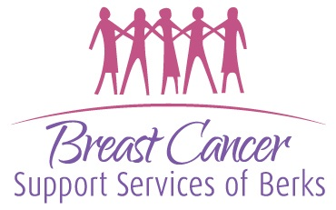
Breast Cancer Support Services of Berks County Administrative Assistant
20 - 25 hours per week Monday – Friday Reports to Executive Director
(some evenings and weekends required for programs and special events/fundraisers)
Skills required: Proficient with Microsoft Office, with exceptional knowledge of Excel, Word and PowerPoint, ability to use basic office equipment, working knowledge of Google Docs, good organizational skills, capacity to manage multiple tasks simultaneously, exceptional time management, ability to communicate with survivors, staff, volunteers and the general public, and ability to work well independently as well as part of a team. Be dedicated to helping and supporting every person affected by breast cancer and keeping all survivor and donor records confidential.
The BCSS Administrative Assistant is responsible for:
- Greeting and directing all guests to the office.
- Answering and directing phone calls to appropriate staff member.
- Responsible for maintaining and overseeing the BCSS library inventory and Dewey Decimal classification. This includes updating and replacing titles and worn books.
- Responsible for maintaining the inventory and appearance of the BCSS fitting room. This includes adding new inventory, rotating stock, and retiring items, as necessary.
- Maintain and oversee office supply inventory -
Place orders as necessary after review with staff members for needs and the ED’s approval.
- Communications -
Respond to all general emails or pass along to appropriate staff member. Maintain current email addresses of all BCSS contacts and update, as necessary. Assist with all bulk mailings for campaigns and events/fundraisers. Assist the special events coordinator with planning and tasks for the fashion show, cornhole tournament, 5K, and trap shoot.
- Administrative tasks -
Oversee various tasks/projects throughout the year related to programming, community projects, organization, and cleaning of office communal areas, decorating for holidays, etc. Ability to move office furniture and lift up to 25 lbs.

Breast Cancer Support Services of Berks County provides hope, emotional support, education, and resources to every person affected by breast cancer.
Interested candidates should send their resume and salary requirements to: ED@bcssberks.org
Breast Cancer Support Services of Berks County is an equal opportunity employer. Survivors are encouraged to apply. Resumes will be accepted from January 23 through February 13, 2026.
Salary range is $12 - $14 per hour based on experience.

