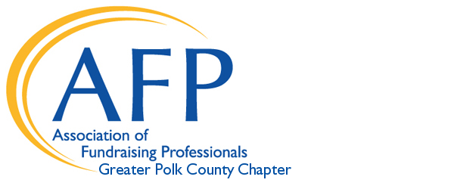

Professional Development Grant Application
Grants of up to $200 are available for Development / Fundraising
specific professional development opportunities (AFP ICON, Planet Philanthropy, Edyth Bush Institute, Nonprofit Leadership Center, etc.)
.
Polk County AFP members in good standing may apply.
Approved grants will be awarded until budgeted funds are depleted.
Grants may be awarded and held until time of approved professional development
(must take place in 2021). Payments will be made to the vendor provider or provided as a reimbursement to the member following confirmation of registration.
Application due March 31, 2021 for any 2021 opportunity.

Name:

Address:

Telephone: E-mail:
Non-profit employer:
Employer Address:

Development position within company:
Years employed there?

What are your job duties?

How long have you been an AFP Member?

Describe your chapter participation – committees, socials, NPD etc.:

What is the professional development opportunity you would like to attend / participate in.
Please explain how this professional development will be valuable to you.

Date of opportunity?
Remaining cost of opportunity if you are awarded this $150-200 grant?

Who will cover that remaining cost?

Required Attachments:
Include the items below along with your signed application:

- A letter of endorsement from your Executive Director, Board Chairman or direct supervisor as to their support and understanding of your application for this grant and plans for professional development opportunity.
- A statement of financial need for this scholarship (limit to one paragraph).
- Flyer, website link, print out or some other documentation describing conference and having highlighted the address funds should be sent, by what date, etc.

Recipient Requirements:

1. Attend the professional development opportunity these funds will support.
2. Submit a one paragraph evaluation on the value of the scholarship within 30
days of conference attendance, to the scholarship contact named on this
application.
3. Become active in the AFP committee of your choice (Please rank your first and second
choices from below, and a Committee Chair will reach out to you.)
______Public Relations / Communications
______IDEA (Inclusion, Diversity, Equity and Access)
______Membership Committee
______National Philanthropy Day

