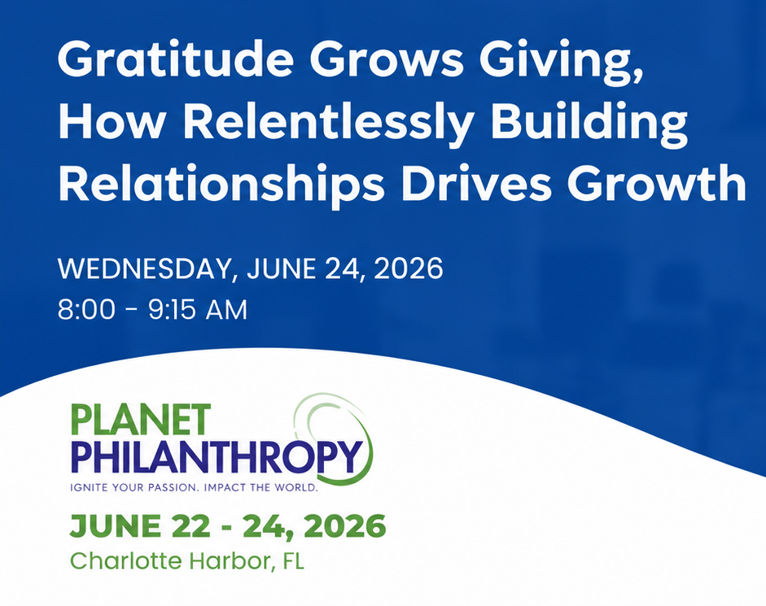
Gratitude Grows Giving:
Relentless Relationship Building Worksheet
Presented by Mandy Cloninger, CFRE

1️⃣ Pareto Principle: Find Your 80/20 (or 90/10)
Identify the top 10–20% of donors responsible for most of your revenue. Focus retention and gratitude efforts here first.
Giving Level | # Donors | % of Total | % of Revenue | Stewardship Lead | Key Action
$100,000+
$50,000–$99,999
$25,000–$49,999
$10,000–$24,999
$5,000–$9,999
$1,000–$4,999
$500–$999
🟣 Where’s your Pareto line? Circle your 80/20 or 90/10 cutoff.

2️⃣ The Relentless Relationship Routine
“Like Curry and Delle Donne at the free-throw line—consistency creates confidence.”
- Make 3 thank-you calls or notes each day
- Review your donor dashboard weekly
- Block 2 hours each week for stewardship only
- Share one donor story with your board each month
Relentless means: no abatement in intensity, consistency, or gratitude.

3️⃣ The Thank-You Sandwich (PB&J Style)
Slice | Example
Bread – Gratitude | “John, thank you so much for your generous $1,000 gift…”
Peanut Butter – Purpose | “Your support helps serve 400 meals—an entire day of dignity.”
Jelly – Sweeten Engagement:  Joy & Invitation | “We’d love to host you for a tour so you can see the impact firsthand!”
Bread – Close with Gratitude | “Thanks again, John—you’re truly part of our family.”
Call/Email Cheat Sheet:
• Best outcome: Personal connection or visit.
• Minimum: Heartfelt voicemail or note.
• Rule of 3: Phone → Email → Handwritten note.

4️⃣ Relentless Retention Metrics
Metric | 2024 | 2025 Goal
# Donors
Retention Rate
Avg Gift
% Top 10% Giving
Board Thank-You Calls Made

🟢 A 10% increase in retention = 50% more revenue.

5️⃣ Commitment Challenge
✳️ I commit to focusing on my top 20% of donors through consistent gratitude.
Signature: ________________________ Date: ___________

