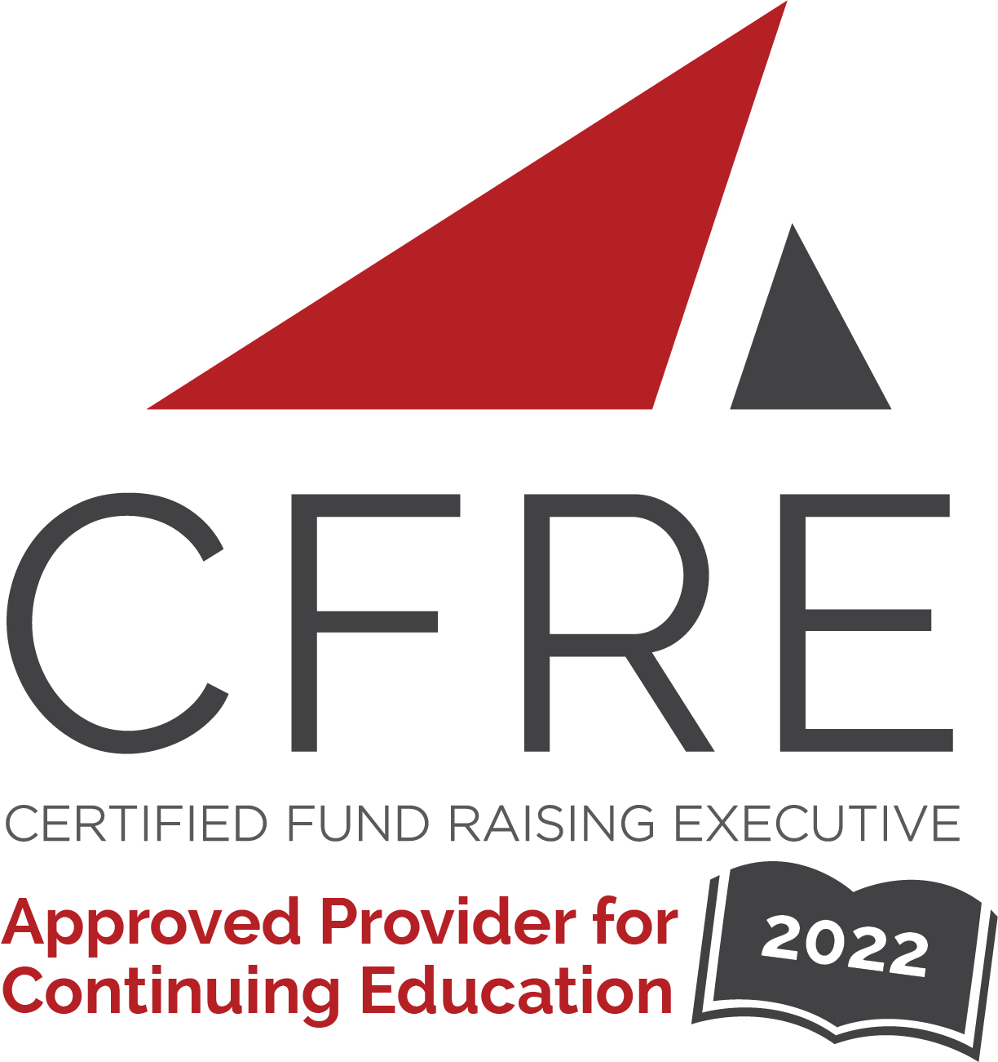  CFRE International has developed this form as a way for you to quickly track (and keep in your files!) the continuing education sessions you have attended. Simply check the boxes next to the sessions you attended. At the end of the conference, add up the total number of hours. Keep this sheet and you will be ready to complete your application form. All of the session slots listed are eligible for continuing education points on your CFRE application for initial certification and/or recertification. Sessions not listed here are not eligible for points. |  | CONTINUING EDUCATION POINTS TRACKER

Activity Organizer: - AFPNEO
Title of Activity: - Professional Development
Names of Presenter(s): - Various

Date: 20, January 2022
What’s Your Story? Storytelling tips to build relationships and grow you impact
8:30 am – 10:00 am (1.5 pts)
Presenter: IMMIX Marketing
Location: TEAMS/Online

Date: 10, February 2022
Diversity in Donor Giving Now and in the Future
8:30 am – 10:00 am (1.5 pts)
Presenter: Dr. Suzanne Allen, The Barberton Community Foundation
Location: TEAMS/Online

Date: 23 March 2022
AFP Webinar: Spark Greater Donor Affinity
Using the Ladder of Engagement
1:00 pm – 2:00 pm] (1.0 pts)
Location-Global Webinar

Date: 28 April 2022
Focus on Philanthropy Conference 2022 (Max CFRE Available is 4.25)
Session 1: 9:30 am – 10:30 am (1.0 pts)
Location: The New Center
- Grant Applications That Win
- Fifty & Flourishing: Building and Executing an Anniversary Campaign
- Developing Your Digital Acquisition Strategy

Morning Session 10:45 am – 11:45 am (1.0 pts)
- Unlocking the Mystery of Professional Advisors & Philanthropic Advising

Focus Keynote Session 12:00 pm-1:15 pm
(1.25 pts)
- The Journey of Giving

Focus Session 2: 1:30 pm – 2:30 pm (1.0 pts)
- How to Keep Calm and Carry On with Your Capital Campaign
- How to Orchestrate an Active and Amazing Board
- Key Elements of an Effective Development Program

Total number of points attained: __________

