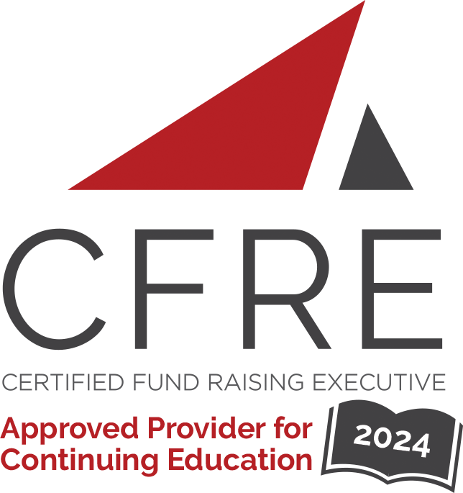  CFRE International has developed this form as a way for you to quickly track (and keep in your files!) the continuing education sessions you have attended. Simply check the boxes next to the sessions you attended. At the end of the conference, add up the total number of hours. Keep this sheet and you will be ready to complete your application form. All of the session slots listed are eligible for continuing education points on your CFRE application for initial certification and/or recertification. Sessions not listed here are not eligible for points. |  | CONTINUING EDUCATION POINTS TRACKER

Activity Organizer: - AFP-GLAC
Title of Activity: - 2024 Educational Programs
Names of Presenter(s): - Various
Dates and Location: - Various

Date: March 27, 2024
11:30 a.m. – 1:00 p.m. (1.5 pts)
- Become a CFRE in 2024

Date: April 24, 2024
12:00 p.m. – 1:30 p.m. (1.5 pts)
- How to be the best Interviewer and Interviewee

Date: May 23, 2024
12:00 p.m. – 1:30 p.m. (1.5 pts)
- Always Be Campaigning? Preparing Your Leaders, Donors and Operations

Date: July 9, 2024
11:30 a.m. – 1:00 p.m. (1.5 pts)
- 2024 Giving USA Report

Date: July 16, 2024
4:30 p.m. – 6:00 p.m. (1.5 pts)
- Dismantling Systemic Barriers within Your Organization

Date: August 22, 2024
12:00 p.m. – 1:30 p.m. (1.5 pt)
- How to Thrive in Turbulent Times: Tools to support your Nonprofit and Team

Date: September 17, 2024
10:30 a.m. – 12:00 p.m. (1.5 pts)
- Womein in the Nonprofit Workspace

Date: October 18, 2024
9:30 a.m. – 11:00 a.m. (1.5 pts)
- “I can’t take that gift” – When Donor Desires and Organizational Missions Are at Odds

Total number of points attained: __________

